

United States International University-Africa
Fall Semester 2025

APT/IST 4900A FINAL-TERM PROJECT

BY
Lesnar Gitonga 669750
Supervisor

Dr. Collins Oduor PhD

UNITED STATES INTERNATIONAL UNIVERSITY-AFRICA
SCHOOL OF SCIENCE AND TECHNOLOGY
December, 2025

This final project report is submitted in partial fulfillment of the requirements of the Applied Information Technology (APT)

Declaration
I declare that this is my original work through my own effort and that it has not been presented in any form for academic or any other reason, to the best of my knowledge. Contributions to this work by any other person or literature have been duly cited.
Student
Lesnar Gitonga Reg No 669750

Signature………………… Date…………………
Lesnar Gitonga Reg No 669750

Signature………………… Date…………………

Supervisor
I confirm that this research project report was carried out by the student under my supervision
Signature……………………. Date…………………
Dr. Collins Oduor PhD
Assistant Professor-Information Systems,
School of Science and Technology
UNITED STATES INTERNATIONAL UNIVERSITY-AFRICA

Acknowledgement
First and foremost, I would like to thank God for giving me the gift of life, health and being with me every step of the way throughout this academic journey, my parents for being there when I needed them, for giving me spiritual, moral and financial support, my friends for their academic and also moral support and all my lecturers especially Dr. Collins Oduor PhD for guiding me through this unit.

Definition of central terms
-Stockout: A situation where a pharmacy or health facility exhausts its inventory of a specific medication or medical supply, rendering it unable to fulfill patient orders.
-Redistribution: The logistical process of transferring surplus medical inventory from a facility with excess stock (donor) to a facility facing a shortage (recipient).
-Interoperability: The ability of different information systems, devices, and applications (e.g., MediMatch and KHIS) to access, exchange, integrate, and cooperatively use data in a coordinated manner.
-Last-Mile Delivery: The final step of the logistics process, moving goods from a transportation hub or warehouse to the final destination (the health facility).
-Cold Chain: A temperature-controlled supply chain that includes an uninterrupted series of storage and distribution activities which maintain a given temperature range, essential for vaccines.

Abstract
Healthcare systems globally struggle to balance supply availability, a challenge most acute in developing nations facing a paradox of simultaneous inventory wastage and acute shortages. In Kenya, this systemic constraint is evidenced by the Kenya Medical Supplies Authority (KEMSA) reporting an order-fill rate of only 57% as of mid-2025, necessitating alternative distribution mechanisms.
Supply chain inefficiencies are exacerbated by fragmented health information systems (such as iLMIS and KHIS) that lack interoperability and an over-reliance on manual, ad-hoc redistribution protocols like phone calls and physical memos. This lack of real-time visibility causes critical delays in emergency interventions and leads to substantial wastage of usable medical products, thereby undermining healthcare equity.
The primary goal of this study was to design, develop, and evaluate MediMatch, a web-based digital platform utilizing geospatial technology to facilitate the transparent and efficient redistribution of surplus medical supplies. Specific objectives included investigating traditional supply chain challenges and determining the benefits of a digital redistribution system in enhancing accountability and reducing inequalities.
Existing literature indicates that while developed nations utilize redistribution platforms, African contexts suffer from digital infrastructure gaps that limit real-time demand visibility. The study draws upon the Technology Acceptance Model (TAM) and Reverse Logistics theory to frame the solution, addressing the "Bullwhip Effect" where lack of information causes demand distortion.
The empirical findings quantified severe disruptions: 56.3% of facilities reported experiencing stockouts on a weekly or monthly basis, while 57.8% identified the wastage of valid medical supplies as a primary operational challenge. Furthermore, 82.8% of respondents rated current manual methods as "ineffective" or "slow". Conversely, 89.1% of stakeholders expressed willingness to pilot the solution, prioritizing "Data-driven Analytics" (45.3%) and "System Integration" (40.6%) as key benefits.
The study concludes that MediMatch is a viable mechanism for enhancing healthcare equity and achieving Sustainable Development Goal 12. System testing confirmed the platform’s capability to handle secure authentication, surplus listing management, and automated logistics coordination, effectively converting slow, informal redistribution into a transparent digital marketplace.
It is recommended to launch a phased pilot implementation targeting the 57.8% of facilities identified as early adopters. Additionally, a technical roadmap should be established to ensure future Application Programming Interface (API) interoperability with the Kenya Health Information System (KHIS) to eliminate data silos.
Future iterations of the project should focus on scaling the system to marginalized counties outside Nairobi where supply disparities are most acute. Technologically, the platform should be upgraded to include AI-driven predictive ordering to forecast stockouts before they occur.
Key words: Medical Supply Redistribution, Geospatial Matching, Healthcare Supply Chain, Waste Reduction, Agile Development, ICT Adoption.

Table of Contents

List of tables
Table 2.1: Comparative Analysis of Existing Medical Supply Redistribution Systems
Table 9.1: Project Implementation Work Plan (Gantt Chart Schedule)
Table 9.2: Project Budget Breakdown

List of figures
Figure 4.1: System Architecture Diagram for MediMatch
Figure 4.2: Use Case Diagram
Figure 4.3: Flow Chart for MediMatch System
Figure 4.4: Class Diagram
Figure 4.5: DFD Level 0 (Context Diagram)
Figure 4.6: DFD Level 1
Figure 4.7: DFD Level 2 (Matching and Notification Subsystems)
Figure 4.8: Entity Relationship Diagram (ERD)
Figure 4.9: Admin Sequence Diagram
Figure 4.10: User Sequence Diagram
Figure 5.1: Gender Distribution of Respondents
Figure 5.2: Age Distribution of Respondents
Figure 5.3: Primary Role Distribution at Facilities
Figure 5.4: Frequency of Stockouts
Figure 5.5: Current Methods for Handling Surplus
Figure 5.6: Effectiveness of Current Methods
Figure 5.7: Main Challenges of Current Supply System
Figure 5.8: Perceived Benefits of MediMatch
Figure 5.9: Willingness to Pilot MediMatch
Figure 7.1: Geospatial Query Logic for Proximity Matching
Figure 7.2: Notification Service Logic
Figure 7.3: Secure Authentication Middleware
Figure 7.4: Frontend Component Structure
Figure 7.5: User Login Screen
Figure 7.6: Create Surplus Listing Interface
Figure 7.7: Suggested Matches View
Figure 7.8: Secure Messaging Interface
Figure 7.9: Admin Control Panel
Figure 7.10: Database Structure - Users Table
Figure 7.11: Database Structure - Listings Table

List of Abbreviations
APT: Applied Information Technology
API: Application Programming Interface
BCG: Bacille Calmette-Guérin (Vaccine)
DFD: Data Flow Diagram
DHIS2: District Health Information Software 2
eCHIS: Electronic Community Health Information System
ERD: Entity Relationship Diagram
HIV: Human Immunodeficiency Virus
HTTPS: Hypertext Transfer Protocol Secure
ICT: Information and Communication Technology
IDE: Integrated Development Environment
iLMIS: Integrated Logistics Management Information System
IST: Information Systems Technology
JSON: JavaScript Object Notation
JWT: JSON Web Token
KEMRI: Kenya Medical Research Institute
KEMSA: Kenya Medical Supplies Authority
KHIS: Kenya Health Information System
LMIS: Logistics Management Information System
MVP: Minimum Viable Product
NGO: Non-Governmental Organization
NHS: National Health Service (United Kingdom)
OECD: Organization for Economic Co-operation and Development
PPE: Personal Protective Equipment
REST: Representational State Transfer
SDG: Sustainable Development Goal
SERU: Scientific and Ethics Review Unit
SQL: Structured Query Language
SSD: Solid State Drive
UHC: Universal Health Coverage
USIU-A: United States International University-Africa
WHO: World Health Organization

Copyright
All the rights reserved. The report may not be photocopied, recorded or otherwise reproduced, stored in a retrieval system or transmitted in any electronic or mechanical means without prior permission of the copyright owner.
Lesnar Gitonga Copyright © 2025

CHAPTER ONE
INTRODUCTION
Introduction
Healthcare systems across the world continue to face persistent challenges in ensuring the availability of medical supplies where they are most needed. While some facilities experience oversupply and waste, others struggle with acute shortages. These imbalances are particularly problematic in low- and middle-income countries, where logistics and supply chains are often fragmented. MediMatch is a proposed digital platform designed to enable efficient redistribution of surplus medical supplies between facilities, thereby improving healthcare equity, reducing waste, and enhancing patient outcomes.
1.1 Background of the Study
Globally, developed countries have experimented with redistribution and donation platforms to manage surplus medical supplies. In the United States, organizations such as MedShare have collected excess equipment and redistributed it to underserved regions. Since its founding, MedShare has shipped medical supplies worth over USD 100 million globally, demonstrating the viability of surplus redistribution at scale (MedShare, 2024). Similarly, in the United Kingdom, the National Health Service (NHS) has piloted internal redistribution programs that allow hospitals to share unused consumables across facilities, particularly during crises such as the COVID-19 pandemic (NHS England, 2022). In Japan, consortiums of hospitals coordinate pooled procurement and redistribution of consumables to smaller clinics, improving both efficiency and cost savings (OECD, 2023).
In Africa, redistribution models are less mature but growing. In South Africa, national and provincial medical stores have used internal redistribution strategies to respond to epidemic surges, reallocating medicines and personal protective equipment across provinces (South African Health Review, 2023). In Nigeria, during disease outbreaks, NGOs and donor programs have coordinated redistribution of surplus drugs and vaccines to underserved states. However, the lack of digital infrastructure and real-time demand visibility has limited their reach and efficiency (WHO Africa, 2023).
In Kenya, the challenge is both acute and systemic. The Kenya Medical Supplies Authority (KEMSA) has faced persistent gaps in fulfilling facility orders, with its order-fill rate estimated at only 57% as of mid-2025 (KEMSA, 2025). Shortages have been widely reported in HIV antiretrovirals, vaccines such as BCG and measles-rubella, and diagnostic kits (HealthcareMEA, 2025). The Ministry of Health has acknowledged these gaps, often resorting to inter-county redistribution as an emergency measure (Kenyan News Agency, 2025). For example, in Turkana County, medical supplies worth KSh 119 million were delivered to address imminent shortages (Kenya News Agency, 2025). Yet, these redistributions are typically manual, relying on memos, phone calls, and ad hoc coordination.
Beyond logistics, systemic weaknesses compound the problem. A 2024 Global Fund audit revealed inconsistencies in Kenya’s stock management, including missing quantities of mosquito nets, suggesting gaps in accountability (Nation Africa, 2024). Counties have also reported debts to KEMSA, constraining procurement and resulting in recurring stockouts (Weekly Vision, 2025). Moreover, Kenya’s health information systems remain fragmented—spanning iLMIS, eCHIS, and KHIS—limiting real-time supply visibility (VillageReach & Ministry of Health, 2025).
These challenges highlight the urgency of new approaches. MediMatch addresses these gaps by introducing a digital redistribution platform where facilities can list surplus supplies, request needed items, and match based on proximity and urgency. Unlike ad hoc redistribution, MediMatch offers transparency, auditability, and scalability, complementing national systems while directly empowering facilities.
1.2 Problem Statement
Healthcare supply chains in Kenya face persistent inefficiencies that directly affect service delivery. While some facilities experience oversupply and eventual wastage of medicines and consumables, others continue to struggle with chronic shortages. The absence of an integrated, transparent redistribution mechanism exacerbates these challenges. The MediMatch platform seeks to address the following key problems:
1. Lack of a Real-Time Redistribution System
Currently, there is no centralized digital platform that allows facilities with surplus medical supplies to connect with those experiencing shortages. Redistribution efforts are handled manually through phone calls, letters, and county health office interventions leading to delays and missed opportunities for timely transfers (Ministry of Health, 2024).
2. Wastage of Medical Supplies
Without redistribution, many facilities end up discarding surplus or near-expiry drugs and consumables, even as other hospitals lack critical items. This wastage undermines Sustainable Development Goal 12 (Responsible Consumption and Production) and increases overall costs in the healthcare system (HealthcareMEA, 2025).
3. Stockouts and Shortages in Underserved Areas
Public health reports indicate frequent shortages of vaccines, HIV drugs, and essential diagnostics in rural and marginalized counties (Kenyan News Agency, 2025). These shortages compromise patient care and result in preventable morbidity and mortality.
4. Poor Visibility and Fragmented Data Systems
Kenya’s health facilities rely on multiple, unintegrated systems such as iLMIS, eCHIS, and KHIS, which provide limited real-time visibility of stock levels. The lack of accurate, consolidated data hinders evidence-based redistribution and planning (VillageReach & MoH, 2025).
5. Limited Transparency and Accountability
Manual redistribution lacks clear audit trails, making it difficult to track where supplies move or to prevent leakages and corruption. Reports of discrepancies in KEMSA stock audits underscore the risks of poor accountability (Nation Africa, 2024).
By addressing these problems, MediMatch aims to create a transparent, efficient, and scalable platform that enhances redistribution, reduces wastage, and ensures that critical supplies reach the facilities and patients that need them most.
1.3 Project Objectives
1.3.1 Overall Goal
To design and develop MediMatch, a digital online platform that facilitates the redistribution of surplus medical supplies between healthcare facilities, ensuring transparency, efficiency, and equity in access.
1.3.2 Systems design and development objectives
The system will be guided by the following unique design and development objectives:
- Geolocation Integration- Implement location-based matching so that facilities can identify nearby donors or recipients, minimizing transport costs and time delays.
- Real-Time Tracking of Supplies- Provide visibility of surplus listings, requests, and matches, allowing stakeholders to monitor redistribution activities transparently.
- User-Friendly Interface- Develop an intuitive, accessible interface that enables healthcare workers with limited digital literacy to quickly post and respond to supply requests.
- Secure Authentication and Role-Based Access- Ensure data protection and restrict access to authorized users through secure login and role-based permissions for donors, recipients, and administrators.
1.3.3 Specific Research Objectives
1.3.3.1 To investigate the traditional challenges in Kenya’s existing supply distribution systems, including delays, stockouts, wastage, and lack of transparency.
1.3.3.2 To determine the benefits of the MediMatch system in addressing these challenges by enabling real-time redistribution, improving accountability, and reducing supply inequalities.

1.4 Project Questions
What are the traditional challenges with the old systems of medical supply distribution, including delays, wastage, lack of accountability, and limited visibility of stock levels?
What are the benefits of the new MediMatch system in addressing these challenges by enabling real-time redistribution, enhancing transparency, and ensuring equitable access to supplies?
1.5 Scope of the Project
The MediMatch project will be implemented as a web-based platform connecting healthcare facilities across Kenya. The system will allow surplus items to be listed by donor facilities and requested by facilities experiencing shortages. Through geolocation services, the platform will match facilities based on proximity to minimize transportation time and cost.
The project scope covers:
-User roles: Donors, Recipients, and Administrators.
-Core features: Secure authentication, listing and requesting of supplies, geolocation-enabled matching, and transparent record-keeping.
-Stakeholders: Public and private hospitals, non-governmental organizations (NGOs), the Kenya Medical Supplies Authority (KEMSA), and the Ministry of Health.
-Proposed location for pilot implementation: Nairobi and surrounding counties, with scalability to national level in subsequent phases.
The project is limited to an MVP prototype but is designed to be scalable and adaptable to Kenya’s broader healthcare ecosystem.

1.6 Limitations of the study
Several challenges are anticipated in the completion of this project within the 14-week timeframe:
-Time Constraints: Limited academic time may restrict the project to a prototype rather than a fully deployed solution.
Mitigation: adopt an agile, iterative development approach, focusing on core features first.
-Resource Limitations: Access to reliable real-time data from health facilities is restricted. Mitigation: use simulated datasets during development and testing.
-Institutional Barriers: Some facilities may be hesitant to share inventory data due to privacy or operational concerns.
Mitigation: enforce strict authentication, anonymize sensitive data, and emphasize transparency benefits.
-Technical Constraints: Dependence on internet connectivity may exclude remote facilities. Mitigation: design lightweight web components optimized for low bandwidth.

1.7 Significance of the study
This study is significant for several reasons:
-For Healthcare Facilities: It reduces wastage and ensures that essential supplies are redistributed before expiry, directly improving service delivery.
-For Patients: It enhances timely access to critical medicines and consumables, potentially reducing morbidity and mortality.
-For Policymakers: It provides a transparent, data-driven platform that can support decision-making and health system reforms.
-For Sustainable Development: It aligns with SDG 3 (Good Health and Well-Being) by promoting better healthcare access, and SDG 12 (Responsible Consumption and Production) by minimizing waste.
-For Academia: It contributes to the body of knowledge on ICT applications in healthcare supply chain management, offering a practical case study from a low-resource context.

CHAPTER TWO
LITERATURE REVIEW
2.0 Introduction
To ground the study in established theory, the design of MediMatch draws upon the Technology Acceptance Model (TAM) as defined by Davis (1989), which posits that perceived usefulness and ease of use are the primary predictors of user adoption. Furthermore, the supply chain inefficiencies observed in the Kenyan context align with the 'Bullwhip Effect' described by Lee et al. (1997), where a lack of visibility causes demand distortion and eventual wastage. The concept of surplus redistribution is framed within Reverse Logistics theory (Rogers & Tibben-Lembke, 2001), while Yadav (2015) provides the critical framework for understanding structural bottlenecks in developing nation supply chains. Finally, the system's compliance aligns with the strategic goals outlined in the Kenya National e-Health Policy 2016–2030 (Ministry of Health, 2020).
2.1 Analysis, comparison and criticism of existing projects with an assessment of strengths and weaknesses of existing projects
2.1.1 MedShare- United States
MedShare, a nonprofit organization based in the United States, specializes in recovering surplus medical supplies and equipment from hospitals and manufacturers for redistribution to under-resourced healthcare facilities globally. Since its inception in 1998, MedShare has shipped supplies valued at more than $100 million to over 100 countries (MedShare, 2024). One of its main strengths is its structured logistics framework, which includes rigorous quality checks, an efficient warehousing system, and a focus on environmental sustainability by reducing medical waste. In addition, MedShare provides biomedical equipment training, ensuring that donated supplies are usable in recipient countries. However, its operations are heavily donor-driven, creating financial sustainability risks if donations decline. Another weakness is that its international scale, while impactful, makes rapid local redistribution difficult because shipments must navigate customs and long-distance transport (Kumar et al., 2023).
2.1.2 NHS Supply Redistribution Program- United Kingdom
The United Kingdom’s National Health Service (NHS) introduced redistribution mechanisms during the COVID-19 pandemic to mitigate shortages of personal protective equipment (PPE), oxygen supplies, and critical medicines. The NHS supply program allowed hospitals to share unused or surplus stock within regional networks, coordinated centrally through NHS Supply Chain (NHS England, 2022). A significant strength of this approach was the speed of redistribution under centralized governance, supported by well-established procurement and logistics infrastructure. This allowed high-demand regions to be supplied quickly, reducing mortality risks during surges. The program also demonstrated transparency and accountability since redistribution was tracked centrally. However, weaknesses included its heavy dependence on crisis-driven conditions, with redistribution efforts declining once demand stabilized. The system is also resource-intensive, requiring significant financial and technical infrastructure that may not be replicable in low- and middle-income countries (Smith & Patel, 2022).
2.1.3 LifeNet International- Uganda (Sub-Saharan Africa)
LifeNet International is a non-governmental organization that partners with faith-based health facilities in Sub-Saharan Africa, particularly in Uganda, Burundi, and Malawi, to improve supply chain efficiency and healthcare outcomes. The organization provides training, implements redistribution practices, and strengthens local health management systems (LifeNet International, 2023). A major strength of LifeNet is its contextual adaptation, as it integrates training and capacity-building alongside redistribution to ensure long-term improvements in healthcare delivery. The model is community-based and highly participatory, enabling trust and buy-in from local stakeholders. However, limitations include its small scale, as its operations cover only a limited number of facilities, restricting its nationwide impact. The organization also faces sustainability challenges, as its reliance on donor funding makes long-term continuity uncertain without diversified financing sources (Ouma & Wanjiru, 2023). Moreover, its relatively limited use of advanced digital platforms constrains its ability to provide real-time redistribution, a gap that a system like MediMatch aims to address.

2.1.4 Summary of comparison of the systems
Table 2.1: Comparative Analysis of Existing Medical Supply Redistribution Systems
Features | MedShare (USA) | NHS Redistribution (UK) | LifeNet International (Uganda- Sub-Saharan Africa)
Cost | X | ✓ | ✓
Easy to Install | X | ✓ | ✓
Easy to use | ✓ | ✓ | ✓
Efficient Database | ✓ | ✓ | X
Good Security | ✓ | ✓ | ✓
Vulnerability assessment | ✓ | ✓ | X

2.2 Literature Review Based on the Specific Research Objectives
2.2.1 Challenges of the existing Systems
1. Manual and Time-Consuming Processes:
Traditional health supply systems rely heavily on paper-based documentation, phone calls, and handwritten requests for supplies. This dependence on manual processes causes delays in redistribution, particularly during emergencies, when time-sensitive medical interventions are critical. According to the World Health Organization Africa (2023), such inefficiencies significantly weaken the responsiveness of healthcare supply chains during crises such as epidemics or mass casualty events. As a result, patients and healthcare facilities suffer from avoidable treatment delays and logistical bottlenecks.
2. Frequent Stockouts in Healthcare Facilities:
Many public health systems in developing countries experience recurring shortages of essential medicines and consumables, often due to forecasting errors, procurement delays, and poor inventory visibility. Kenya has repeatedly faced shortages of antiretroviral and pediatric vaccines, forcing patients to travel long distances to seek care (HealthcareMEA, 2025). Such stockouts erode trust in public healthcare institutions and disrupt ongoing treatment programs, particularly for chronic diseases that require uninterrupted medication access.
3. Wastage of Medicines and Supplies:
Large quantities of medical supplies expire or remain unused due to lack of coordination between surplus and deficit facilities. Without a centralized digital redistribution framework, hospitals often discard supplies that could have been reallocated to needy areas. MedShare (2024) estimates that billions of dollars’ worth of usable medical supplies go to waste annually worldwide. This not only represents a financial loss but also an ethical and humanitarian concern, as preventable deaths occur in areas suffering from shortages.
4. Fragmentation of Data and Information Systems:
In Kenya, multiple health information platforms such as iLMIS, KHIS, and eCHIS, operate in isolation, each focusing on specific administrative functions without interoperability. This fragmentation leads to data silos where different facilities report either shortages or surpluses without mutual visibility (VillageReach & Ministry of Health, 2025). Consequently, decision-makers cannot form a complete picture of supply distribution, delaying coordination and resource balancing across facilities.
5. Weak Accountability and Transparency Mechanisms:
Weak internal controls and the absence of digital audit trails enable misuse, diversion, or theft of supplies. A 2024 KEMSA audit exposed discrepancies and missing medical commodities, suggesting deep-rooted inefficiencies and corruption (Nation Africa, 2024). The lack of a unified system to trace each transaction from procurement to delivery reduces donor confidence and limits transparency in resource utilization.
6. Geographical Inequality in Distribution:
Urban hospitals generally receive timely deliveries and better logistical support, while rural and marginalized areas experience frequent supply gaps. The OECD (2023) found that logistical and infrastructural disparities significantly widen healthcare inequities between regions. Rural facilities, often located in hard-to-reach areas, suffer the most from inconsistent deliveries and poor communication networks, leaving patients underserved.
7. Logistical and Infrastructure Limitations:
Poor transport infrastructure, long delivery distances, and insecurity along certain routes make supply redistribution unreliable and expensive. In counties like Turkana and Marsabit, medical deliveries are frequently delayed or lost due to bad roads and insecurity (Kenya News Agency, 2025). These barriers lead to increased operational costs and discourage timely redistribution between health facilities.
8. Financial and Governance Fragility:
Health supply systems in many African countries, including Kenya, depend heavily on donor funding, which makes them vulnerable to external economic fluctuations. When donor support declines, procurement and distribution operations are severely disrupted. For example, The Star (2025) reported that Kenya faced an impending shortage of HIV medicines due to a reduction in global donor support, exposing the fragility and unsustainability of current models.

2.2.2 Benefits of the New System (MediMatch)
1. Real-Time Redistribution and Responsiveness:
The MediMatch system provides a digital platform that allows hospitals and clinics to instantly list surplus or required medical items. This reduces delays associated with manual communication and accelerates redistribution during urgent situations. By enabling real-time visibility, MediMatch ensures that supplies reach the facilities that need them most, thereby improving overall system agility (WHO Africa, 2023).
2. Reduction of Wastage and Improved Resource Utilization:
Through its redistribution model, MediMatch prevents waste by allowing facilities to transfer near-expiry supplies to others that can use them promptly. This approach minimizes medical product loss and ensures that existing resources are used efficiently. HealthcareMEA (2025) observes that such systems significantly reduce supply waste and improve cost-effectiveness in healthcare logistics.
3. Promoting Equitable Access Across Regions:
MediMatch bridges the gap between urban and rural facilities by creating a shared visibility platform for all participants. This ensures that remote or low-income areas can access essential supplies that were previously concentrated in major hospitals. The platform thereby contributes to greater healthcare equity and supports the national goal of achieving Universal Health Coverage (UHC).
4. Enhanced Accountability and Transparency:
Each transaction made on MediMatch is automatically logged and timestamped, producing a verifiable audit trail. This transparency discourages fraudulent practices and builds trust among donors, government agencies, and implementing partners. Nation Africa (2024) emphasizes that such traceable systems are vital in strengthening institutional integrity and public accountability in healthcare supply chains.
5. Integration with Existing Health Information Systems:
MediMatch is designed to interface seamlessly with existing national systems like KHIS and iLMIS to avoid duplication and data conflicts. By synchronizing inventory records, the platform gives health administrators a comprehensive view of supply levels across multiple facilities. According to VillageReach and the Ministry of Health (2025), such interoperability increases efficiency and ensures cohesive decision-making in healthcare logistics.
6. Cost Efficiency and Resource Optimization:
By enabling local redistribution before initiating new purchases, MediMatch helps reduce procurement costs. Facilities can fulfill urgent needs using nearby resources, saving both time and money. This fosters sustainability by optimizing internal supply networks and reducing dependence on external donors.
7. Data-Driven Decision-Making:
The platform continuously collects and analyzes data related to supply trends, usage rates, and redistribution frequency. These insights help policymakers identify demand patterns, forecast shortages, and plan future procurement more effectively. Such analytics-driven approaches improve resilience and efficiency in national healthcare planning (WHO Africa, 2023).
8. Scalability and Adaptability of the Platform:
MediMatch is built on a modular architecture that can easily scale from pilot deployment to regional and national levels. The system can also be adapted to other contexts, such as cross-border aid coordination and emergency humanitarian response (Smith & Patel, 2022). This flexibility ensures its long-term relevance and potential for expansion across Africa.
2.3 Conclusion
The literature confirms that traditional medical supply systems face persistent challenges including delays, stockouts, wastage, poor data integration, weak accountability, inequities, logistical barriers, and financial fragility. MediMatch addresses these gaps through real-time redistribution, reduced wastage, fairer access, stronger transparency, integration with existing platforms, cost efficiency, data insights, and scalability. By bridging these weaknesses, MediMatch represents a transformative step towards building sustainable, transparent, and equitable healthcare supply systems.

CHAPTER THREE
RESEARCH DESIGN AND METHODOLOGY
- Introduction
This chapter outlines the methodological framework used in the design, development, and evaluation of the MediMatch system. It describes the overall research design, the locality of the project, the target beneficiaries, and the research approach applied. Furthermore, it elaborates on data collection techniques, analysis methods, and ethical considerations. The methodological approach was carefully chosen to ensure that the project objectives are achieved and that the outcomes are scientifically valid, reliable, and replicable. By adopting this structured methodology, the project ensures that the system not only addresses the identified gaps but also demonstrates practicality and sustainability within real-world healthcare settings.
3.1 Locality of the project and Beneficiaries to the project
The MediMatch project will be implemented and tested in Nairobi County, Kenya, which provides an ideal case study environment. Nairobi has a wide range of healthcare institutions, from large referral hospitals such as Kenyatta National Hospital and Aga Khan University Hospital, to small community health centers and private clinics. This mix of well-resourced and under-resourced facilities makes Nairobi a representative sample for testing a supply redistribution system. Large hospitals often experience surpluses in consumables and donations, while smaller clinics frequently face shortages due to limited budgets and supply-chain bottlenecks.
The choice of Nairobi as the project locality is also influenced by its high population density, rapid urbanization, and the growing demand for equitable healthcare services. According to the Kenya Ministry of Health (2023), disparities in supply distribution remain one of the key challenges in ensuring universal healthcare access. Implementing MediMatch within this context will therefore allow for testing of both the technical feasibility and the social impact of the system.
Beneficiaries of the project can be categorized into three main groups. First, healthcare facilities will benefit by having greater visibility into supply surpluses and shortages, reducing waste and stockouts. Second, healthcare workers and administrators will experience reduced workload and enhanced decision-making through access to accurate data and streamlined redistribution processes. Third, patients and the wider community will benefit from more reliable access to essential medical supplies, leading to improved treatment outcomes, reduced delays, and higher trust in the healthcare system. Secondary beneficiaries include government agencies, NGOs, and international donors who will gain transparency and accountability through system-generated reports.
3.2 Research Design approach –DESCRIPTIVE
The study employs a descriptive research design, which is most appropriate for this project because it aims to describe, analyze, and document the challenges associated with existing supply chain processes, while also demonstrating how the MediMatch system provides improvements. Descriptive design enables the collection of both qualitative and quantitative information to provide a holistic picture of the healthcare supply redistribution environment.
This approach was chosen because it does not manipulate variables, but instead observes existing patterns, describes them in detail, and uses those findings to inform the design of a technological solution. For instance, by documenting the frequency of supply shortages in community health centers and contrasting them with stock surpluses in larger hospitals, the research highlights the inefficiency of manual redistribution mechanisms. Similarly, by interviewing healthcare administrators, the study captures qualitative insights into pain points such as delays, paperwork, and lack of coordination.
The descriptive approach also supports iterative evaluation of MediMatch. The system is tested against real-world scenarios, and descriptive analysis is used to record user experiences, adoption challenges, and performance benchmarks such as average request processing time. This makes it possible to refine the system continuously, ensuring alignment with stakeholder needs.
3.3 Population of the study(Target group) and Sampling method
The target population for this project comprises healthcare institutions and administrators operating within Nairobi County. This includes public hospitals, mission hospitals, community clinics, and private healthcare facilities. Additionally, government agencies such as the Ministry of Health and NGOs involved in healthcare distribution are included as stakeholders. Patients are also considered indirect participants, as they represent the ultimate beneficiaries of improved supply availability.
A purposive sampling strategy is adopted to identify representative facilities that reflect both the extremes and averages of Kenya’s healthcare system. Large referral hospitals are included to represent supply-rich facilities, while smaller dispensaries and clinics represent supply-deficient institutions. This ensures that data collected provides a balanced understanding of redistribution challenges and opportunities. The sample size for pilot implementation is expected to include at least 5–8 healthcare facilities with varying capacities, ensuring diversity and comprehensiveness in the evaluation.
3.4 Data collection methods and Primary Data collection methods
Multiple data collection methods are applied to ensure validity and reliability of the findings. These include:
-Literature Review: Peer-reviewed journals, government health reports, and global case studies on healthcare supply chain systems form the secondary data source. This helps in benchmarking MediMatch against international best practices.
-Interviews: Semi-structured interviews with healthcare administrators and supply chain officers provide first-hand insights into the challenges of current systems.
-Questionnaires: Distributed to healthcare staff, questionnaires collect quantitative data on supply shortages, response times, and satisfaction with the redistribution process.
-System Usage Logs: During pilot deployment, MediMatch will collect usage statistics such as number of listings posted, number of requests matched, and response times. These logs will be crucial for evaluating system performance.
Combining these methods allows triangulation of findings, increasing credibility and depth of analysis.
3.5 Data analysis methods
The data collected will be analyzed using both qualitative and quantitative techniques. Descriptive statistics such as frequencies, percentages, and averages will be used to analyze numerical data from questionnaires and system logs. For instance, the average time taken to match supply requests before and after MediMatch deployment will be compared to evaluate efficiency gains.
Qualitative data from interviews will be analyzed thematically. Recurring themes such as “delayed communication,” “manual reporting,” or “lack of transparency” will be coded and grouped to reveal common pain points. Similarly, positive outcomes from using MediMatch, such as “faster redistribution” or “better accountability,” will be captured and analyzed. This mixed-methods approach ensures that both the numerical impact and the lived experiences of stakeholders are reflected in the findings.
3.6 Testing plan for the system
Ethical compliance is critical in a project that deals with sensitive health-related data. All participants in the study, including administrators and healthcare staff, will be informed of the purpose and scope of the research, and their consent will be obtained before any interviews or questionnaires are conducted. No personal patient data will be collected; the focus is strictly on institutional supply management and redistribution patterns.
Confidentiality will be maintained by anonymizing participant responses and ensuring that raw data is stored securely with restricted access. The system itself will employ standard security mechanisms, including authentication, encrypted communication, and strict access control, to prevent unauthorized access. The study also ensures compliance with Kenyan Data Protection laws (2019) and aligns with global ethical principles in health informatics research.
3.7 Ethical clearance considerations
Before undertaking the implementation of the MediMatch project, ethical clearance is a crucial prerequisite to ensure the research aligns with institutional and national guidelines. In Kenya, all research projects involving human participants or data from health institutions must be reviewed and approved by recognized ethics bodies such as the Kenya Medical Research Institute (KEMRI) Scientific and Ethics Review Unit (SERU) or a relevant university ethics review board. This process provides an independent assessment of the project’s design, ensuring that it does not expose participants or institutions to harm, breaches of confidentiality, or conflicts of interest.
For MediMatch, ethical clearance will be sought through the United States International University-Africa (USIU-A) Institutional Ethics Review Committee, given its mandate over student-led research projects. Once approved, formal letters of authorization will also be obtained from participating healthcare institutions and the Ministry of Health to allow for data collection, interviews, and pilot testing of the system.
The clearance process requires submission of a detailed research proposal, informed consent forms, and data protection protocols that demonstrate compliance with the Kenya Data Protection Act (2019). This ensures that sensitive health-related data is handled securely, anonymized where necessary, and only used for the purposes of this study. No patient-identifiable information will be collected, and participation of staff will be entirely voluntary.
By securing ethical clearance, the project demonstrates accountability, legitimacy, and commitment to upholding the highest standards of professional and academic integrity. This step also builds trust with stakeholders, ensuring their willingness to collaborate in the testing and eventual scaling of the MediMatch system.

CHAPTER FOUR
SYSTEMS ANALYSIS AND SYSTEM DESIGN
- Introduction
This chapter specifies the analysis and design foundations for MediMatch. It defines the functional and non-functional requirements, the system’s architecture, and the conceptual models used to communicate how components interact and how data flows through the platform. The objective is to translate the project vision into verifiable specifications that guide implementation and testing, ensure stakeholder alignment, and reduce rework risk. Subsequent sections present stakeholder needs and trace them to features; then, models (use case, data-flow, ERD, and sequence diagrams) illustrate behavior and structure to support build and validation.
4.1 System Requirements
4.1.1 Functional Requirements
Functional requirements specify the core operations and services that MediMatch must perform. These are the features that directly enable healthcare facilities to interact, share resources, and improve redistribution efficiency.
User Registration and Authentication:
The system will provide a secure registration and login process for hospitals, clinics, and administrators. Each user will have a unique account protected by encrypted credentials. This functionality is essential to ensure that only authorized institutions can post, request, or approve listings. Authentication will be handled using JSON Web Tokens (JWT) to prevent unauthorized access and enhance system integrity.
Profile Management:
Every registered user will have access to a profile section where they can update organizational details, including facility name, location, and contact information. This ensures that data shared on the platform remains accurate and that other institutions can identify the source of a listing or request. Profile management also supports location-based matching by providing relevant geographical data.
Listing Creation and Management:
MediMatch will enable facilities to create listings of both surplus and required medical supplies. Users can specify details such as item name, quantity, expiration date, and condition. This feature forms the foundation of the redistribution mechanism, allowing healthcare facilities to broadcast their needs or available resources in real time. The system will validate inputs to prevent erroneous data and enhance reliability.
Automated Supply Matching:
A core feature of MediMatch is its intelligent matching algorithm, which pairs facilities based on item type, location, and urgency. When a facility posts a request, the system automatically searches for matching surplus items within a defined radius. This function minimizes delays and human error, ensuring that supplies reach where they are needed most efficiently.
Search and Filtering Mechanism:
The system will allow users to search and filter listings using multiple criteria such as category, location, and availability. This makes it easier for users to quickly locate relevant items. Advanced filtering options—such as sorting by expiry date or distance—will enhance usability and support faster decision-making.
Notification and Alert System:
MediMatch will provide an integrated notification system to alert users about new matches, approved requests, or expiring listings. Notifications will appear both in-app and via email, ensuring that users remain updated even when not logged in. This feature promotes responsiveness and timely actions between donor and recipient facilities.
Transaction Tracking and Reporting:
The system will generate detailed reports and maintain transaction histories for all redistribution activities. This includes tracking the date, donor, recipient, and type of item shared. Administrators can use these records to monitor performance, detect inefficiencies, and produce analytics for reporting to oversight bodies such as the Ministry of Health.
Data Backup and Recovery:
To ensure business continuity, MediMatch will implement automatic data backup and recovery mechanisms. Regular backups will be stored securely, minimizing data loss risks in case of system failure. This feature guarantees the reliability and sustainability of the platform in long-term operations.
These functionalities collectively ensure that MediMatch fulfills its mission of enhancing transparency, speed, and equity in medical supply redistribution.
4.1.2 Non - Functional Requirements
Non-functional requirements define the quality attributes of MediMatch—how efficiently, securely, and reliably it performs its operations. These aspects are crucial to user satisfaction, long-term maintainability, and system scalability.
Performance:
The system must deliver high responsiveness, ensuring that operations such as listing searches, user logins, and match suggestions are completed within three seconds. Quick performance improves user experience and encourages frequent use of the platform, especially in emergency scenarios where time is critical.
Scalability:
MediMatch will be designed to accommodate increasing numbers of users, listings, and transactions without compromising performance. The system architecture will support horizontal scaling, allowing integration with larger databases such as Kenya Health Information System (KHIS) or Logistics Management Information Systems (LMIS) as adoption grows nationwide.
Security:
Given that MediMatch handles sensitive institutional and logistical data, security is a top priority. The system will employ data encryption, role-based access control, and secure communication protocols (HTTPS). All passwords will be hashed using modern cryptographic algorithms such as bcrypt. Authentication tokens (JWT) will be time-bound to prevent misuse.
Usability:
The platform’s user interface will be simple, intuitive, and accessible to healthcare professionals with varying levels of technical literacy. Clear navigation, minimal input requirements, and visual feedback will help users accomplish tasks efficiently. Usability testing will be conducted to ensure smooth interactions on both desktop and mobile devices.
Reliability:
The system must maintain a minimum uptime of 98% to guarantee consistent access for all users. Mechanisms such as error logging, redundancy, and health monitoring will be implemented to ensure reliability. Failover recovery processes will allow quick restoration in the event of technical issues.
Portability:
MediMatch will be platform-independent, deployable on various operating systems (Windows, Linux, macOS) and web browsers. Its design will allow easy migration between environments without the need for significant configuration changes, increasing flexibility for future upgrades or regional deployment.
Maintainability:
The system will adopt modular design principles, separating key components such as authentication, matching, and reporting into independent modules. This structure simplifies troubleshooting and facilitates updates or feature extensions in the future. The use of TypeScript and documented APIs will improve code clarity and reduce maintenance costs.
Ethical and Legal Compliance:
MediMatch will comply with Kenya’s Data Protection Act (2019), ensuring responsible data handling and user consent. It will also align with global digital health ethics as outlined by the World Health Organization (2022), emphasizing privacy, transparency, and fairness. Ethical compliance guarantees that the platform not only functions efficiently but also respects the rights of all stakeholders.
4.2 Stakeholders
The success of the MediMatch system depends on the active involvement of diverse stakeholders who contribute to its design, implementation, and sustainability. Each stakeholder plays a specific role in ensuring that the redistribution of medical resources is efficient, transparent, and aligned with national healthcare goals. Understanding their interests, expectations, and influence is therefore essential in guiding both technical and policy-related decisions during the system’s development and deployment.
Healthcare Facilities (Primary Users):
Hospitals, clinics, and health centers constitute the primary user group. They are the direct beneficiaries of MediMatch since it allows them to post surplus supplies, request needed commodities, and receive timely updates about available resources. Their participation forms the foundation of the redistribution network. These facilities gain operational efficiency, reduced wastage, and improved access to essential commodities, particularly during shortages.
Healthcare Workers and Administrators:
This group represents the operational staff who will manage system interactions at the facility level. They are responsible for entering data, validating listings, approving matches, and ensuring that redistributed items reach the intended recipients. Their cooperation ensures data accuracy and timely coordination between donor and recipient facilities. Administrators also generate reports for internal monitoring and external accountability.
Government Agencies (Ministry of Health and County Health Departments):
The Ministry of Health acts as a supervisory and regulatory stakeholder, ensuring that the redistribution of medical resources adheres to national healthcare standards. County health departments oversee implementation at local levels, providing logistical support and monitoring compliance. Government involvement also ensures that the system integrates with national health databases such as KHIS, LMIS, and DHIS2 to enable unified data management and policy evaluation.
Donor Organizations and Non-Governmental Organizations (NGOs):
Donors and NGOs play a crucial role by providing technical and financial support. Many of them already fund medical supply programs, and the MediMatch system enables them to track the impact of their contributions through transparent reports and data-driven insights. Their involvement promotes system credibility, ensures sustainability, and enhances cross-border collaboration during emergencies.
System Developers and Technical Team:
The technical team is responsible for the design, implementation, testing, and maintenance of MediMatch. Their main task is to ensure that the system remains stable, secure, and scalable. Developers also manage user feedback, patch updates, and introduce enhancements based on emerging user needs or technological trends.
Patients and the General Public:
Although they are not direct users of the platform, patients benefit indirectly from the efficiency of MediMatch. A well-functioning redistribution system ensures consistent availability of medicines and medical equipment, reducing treatment delays and improving health outcomes. In the long term, public trust in the healthcare system increases as access disparities reduce.
Partners and Logistics Providers:
In the future, MediMatch aims to collaborate with logistics companies to facilitate the actual transportation of donated supplies between facilities. Such partnerships will strengthen the supply chain by reducing delays and ensuring the safe, traceable movement of medical goods.
In summary, MediMatch connects diverse stakeholders, each with distinct but interdependent roles, into a unified digital ecosystem. Their combined participation ensures the system’s practicality, transparency, and scalability in addressing medical supply challenges across Kenya and potentially other African regions.
4.3 System Models
System modeling is a vital component of the system design phase, as it transforms conceptual requirements into tangible representations that guide both development and testing. These models provide a structured visualization of how MediMatch functions internally and externally, helping stakeholders, designers, and developers understand data flow, user interactions, and logical dependencies.
Through system modeling, the MediMatch project ensures consistency between what users expect and how the system operates. The models discussed in this section include system architecture, use case diagram, flow chart, class diagram, data flow diagrams (DFD), and entity relationship diagrams (ERD). Each model focuses on a specific dimension of the system’s design i.e structural, behavioral, or relational, and collectively, they establish the technical backbone for implementation.
4.3.1 Systems Architecture
The revised system architecture, shown in Figure 4.1, is built on a modern, component-based three-tier model that separates concerns. A Healthcare User interacts with the Presentation Layer, a client-side application built in React and TypeScript. This client communicates via HTTPS/REST API calls to the Application Layer, which is a Node.js and Express backend server. This backend is not a monolith; it is composed of distinct services, including an Auth Service using JWT, a Listing Service, and the core Matching Service. This service communicates with the Location Service to find nearby facilities and the Notification Service to send alerts. Finally, the Data Layer uses a PostgreSQL database with PostGIS extensions to handle all data persistence and complex geospatial queries for matching.
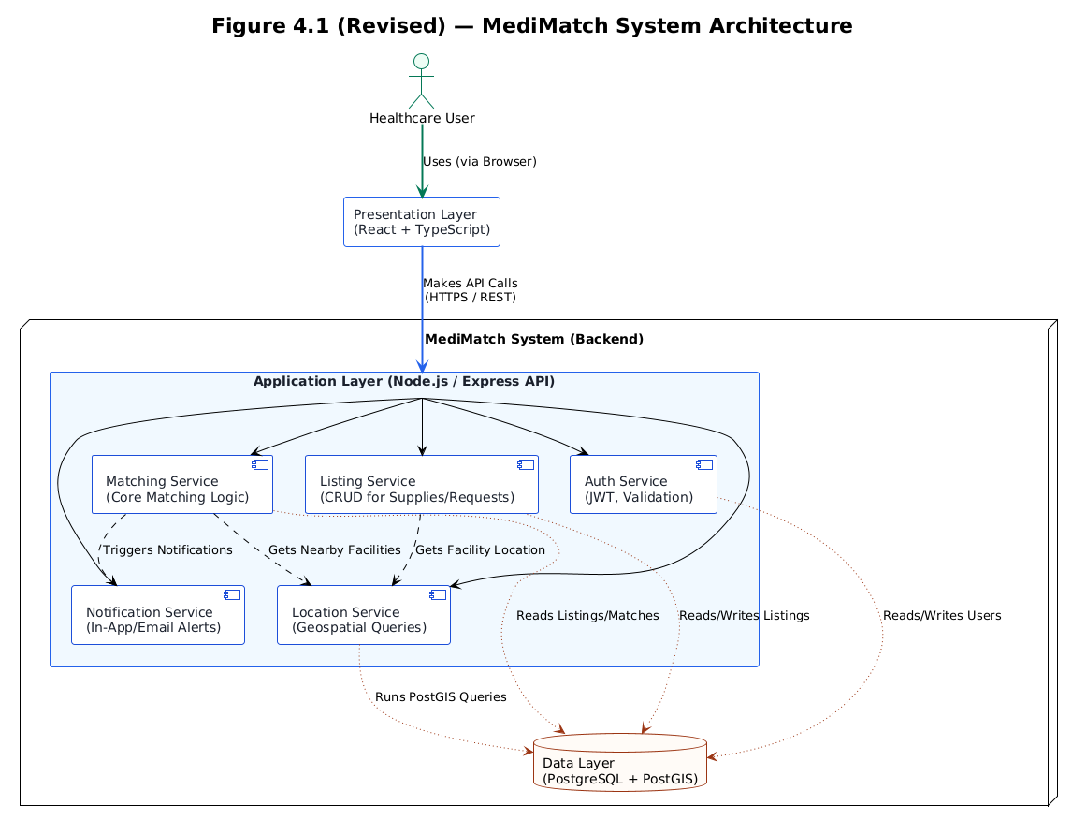
Figure 4.1: System Architecture Diagram for MediMatch (Client → API Server → Database)

4.3.2 Use Case Diagram
Figure 4.2 presents the Use Case Diagram, which provides a high-level functional view of how different users interact with the MediMatch system. It clearly identifies the three primary actors: the Donor Facility, the Recipient Facility, and the Administrator . Core system functions, or use cases, like Create Surplus Listing and Create Need Request are mapped to the actors who perform them. The diagram also effectively uses <<include>> relationships to show shared, mandatory functions like Validate Input. It also models optional paths, like a Counter-proposal, using an <<extend>> relationship, ensuring a complete visualization of all user-system interactions.
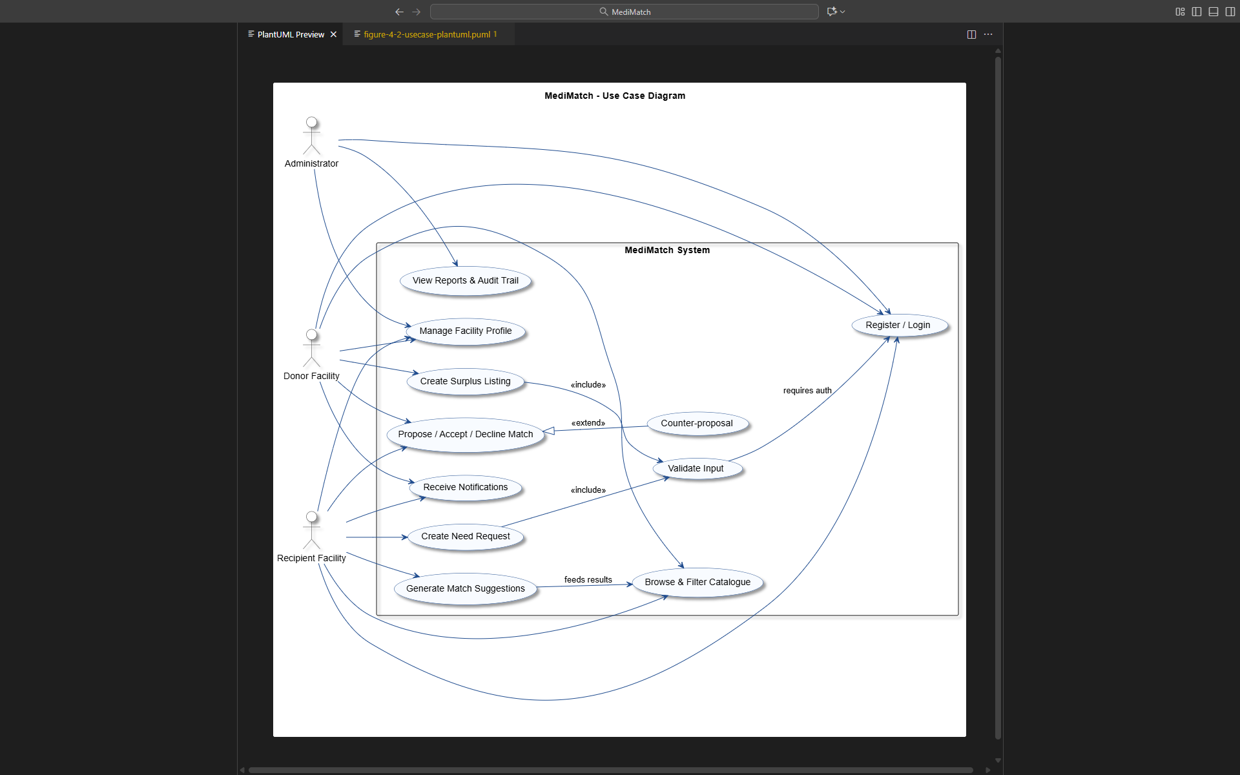
Figure 4.2: Use Case Diagram showing the interactions among Administrator, Donor Facility, Recipient Facility, and MediMatch core functions

4.3.3 Flow chart
The system flow chart in Figure 4.3 illustrates the step-by-step logical path a user takes within the MediMatch platform, visualizing the process from start to finish. The process begins with the User Session swimlane, which covers the initial Login / Register decision and subsequent validation of credentials. After successful authentication, the user moves to Action Selection, where they can choose one of three main paths: Surplus Listing, Supply Request, or Browse Catalogue. All paths that involve data entry include validation and saving to the database. The final Matching & Outcome swimlane details the backend logic: the algorithm runs, notifications are sent to both donor and recipient, and a final Generate Reports & Audit Logs step ensures all transactions are recorded for accountability.
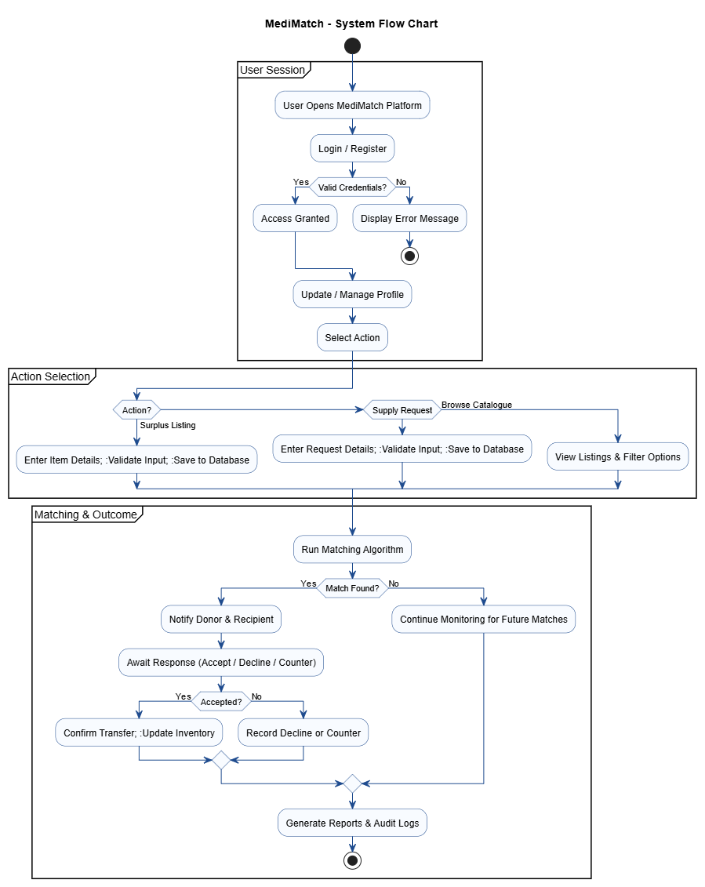
Figure 4.3: Flow Chart for MediMatch System illustrating the logical sequence of user authentication, data validation, matching, notification, and reporting processes.
4.3.4 Class Diagrams
Figure 4.4 provides the Class Diagram, which defines the static structural blueprint of the MediMatch system using object-oriented principles. It outlines the main classes, such as User, Facility, Listing, Request, Match, and Administrator. Each class box clearly shows its key attributes (data fields like itemName or passwordHash) and its methods (functions like createListing() or generateReport()). The diagram also maps the critical relationships and multiplicity between these classes. For example, it shows that one Administrator manages many Facility objects, and one Facility can submit many Requests, visually representing the system's database structure and business rules.
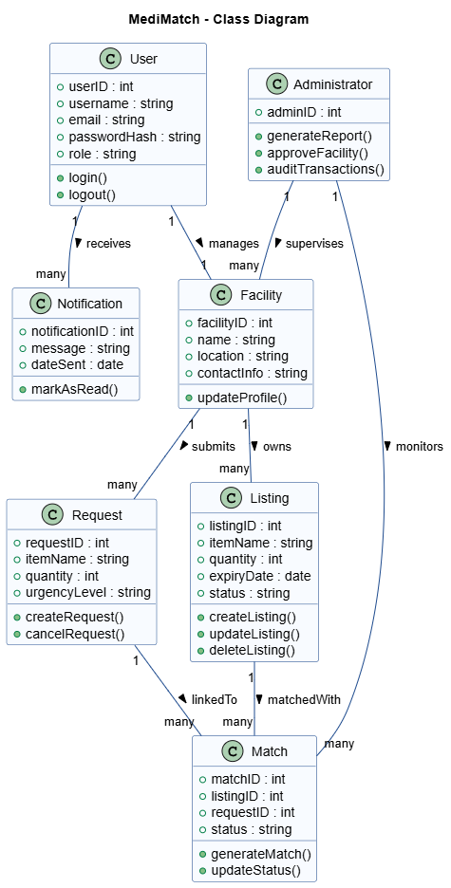
Figure 4.4: Class Diagram for MediMatch System showing main entities, their attributes, operations, and relationships between users, facilities, listings, requests, and matches.
4.3.5 Data Flow Diagram
4.3.5.1 Context Diagram Level 0
The DFD Level 0, or Context Diagram, is shown in Figure 4.5. It provides the highest-level, most abstract view of MediMatch, representing the entire system as a single, unified process. This diagram is crucial for defining the project's scope and boundaries. It clearly illustrates the system's primary interactions with all external entities, which are the Donor Facility, Recipient Facility, and Administrator. The arrows show the main data flowing in and out of the MediMatch System process. This includes inputs like Surplus Listing Info and Supply Requests, as well as outputs like Match Confirmations and Reports & Audit Logs .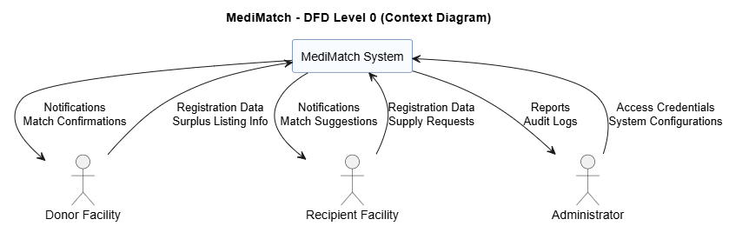
Figure 4.5: DFD Level 0 (Context Diagram) showing the interaction between external entities and the MediMatch system.
4.3.5.2 Level 1 Diagram
Figure 4.6 shows the DFD Level 1, which explodes or decomposes the single process from the Context Diagram into its main functional sub-processes. This provides an internal view of how data moves between these core functions and the system's data stores. The diagram clearly shows the key processes: User Authentication, Profile Management, Listing & Request Handling, the Matching Engine, and Notifications & Reporting. It also visualizes the three primary data stores that manage the system's information: the User Database, the Listings/Requests Repository, and the Match Records store.
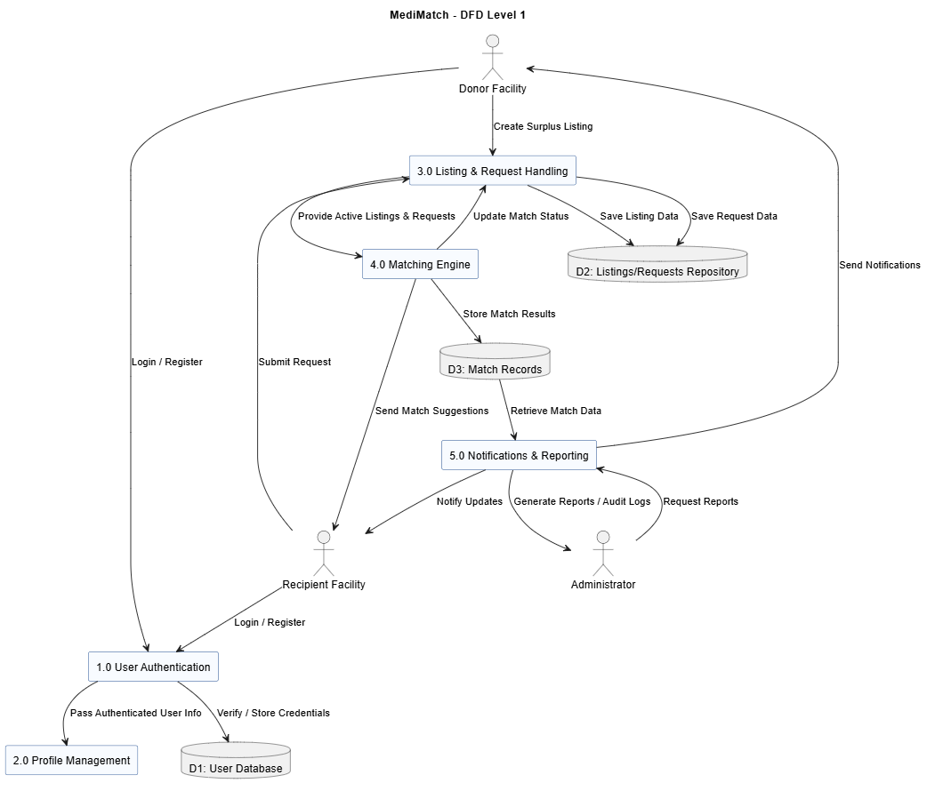
Figure 4.6: DFD Level 1 showing internal data processes, data stores, and flow of information within the MediMatch platform.
4.3.5.3 Level 2 Diagram
The DFD Level 2 in Figure 4.7 provides a highly detailed, granular look inside the Matching Engine and Notification subsystems, which were shown as simpler processes in the DFD Level 1. It illustrates the complex internal workflow of the matching logic. The flow begins with Retrieve Active Listings and Retrieve Active Requests from the Listings/Requests Repository. This data is fed into the Run Matching Algorithm process. The results are then passed to Validate Match & Store Record, which saves the data to Match Records and also triggers the Generate Notifications subsystem, ensuring all actors are alerted to the new match.
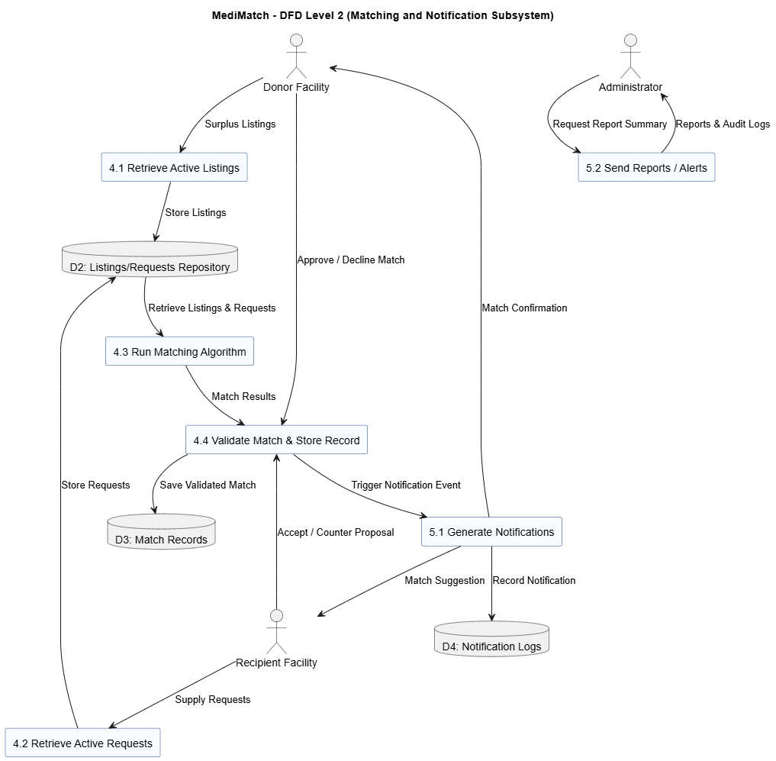
Figure 4.7: DFD Level 2 for MediMatch showing detailed data flow for the Matching and Notification subsystems, including interactions with donors, recipients, and administrators.
4.3.6 Entity Relationship Diagram
Figure 4.8 presents the Entity Relationship Diagram (ERD), which models the logical structure and blueprint for the MediMatch database. It identifies the system's main entities, such as User, Facility, Listing, Request, Match, Notification, and TransactionLog. For each entity, it lists the essential attributes (columns) that will be stored, such as user_id, itemName, or expiry_date. Most importantly, it defines the cardinality and relationships between entities using crow's foot notation. This clearly shows one-to-one, one-to-many, and many-to-many relationships, like a User belongs to one Facility and a Match is recorded in one TransactionLog.
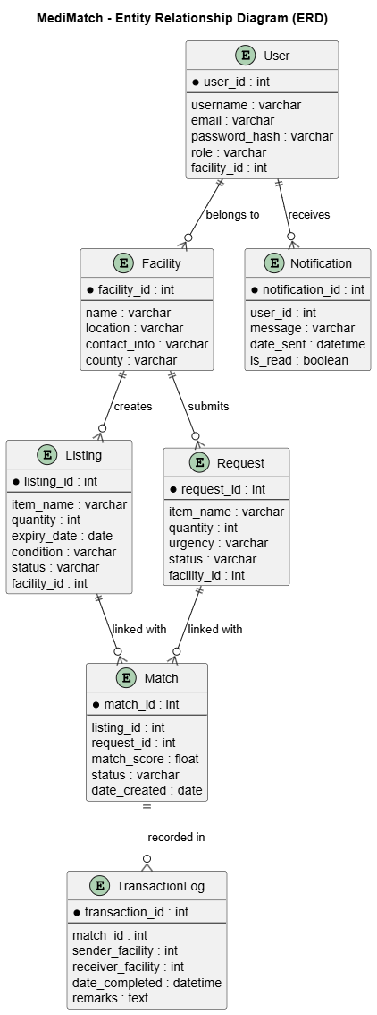
Figure 4.8: Entity Relationship Diagram (ERD) for MediMatch showing relationships among users, facilities, listings, requests, matches, and notifications that underpin the system’s database design.
4.3.7 Sequence Diagram
4.3.7.1 Admin Sequence Diagram
The Admin Sequence Diagram in Figure 4.10 illustrates the time-ordered sequence of interactions an administrator performs. It clearly shows the flow of messages between the four main lifelines in this process: the Administrator (actor), the Frontend (UI), the Backend Server, and the Database. The diagram is logically grouped into three main tasks. It begins with the Login sequence, showing credential validation. This is followed by a Manage Data sequence, where the admin requests facility data. Finally, the Reporting sequence shows the admin generating a summary report, which involves the backend fetching data, saving the report, and sending a Report Generated Successfully notification.
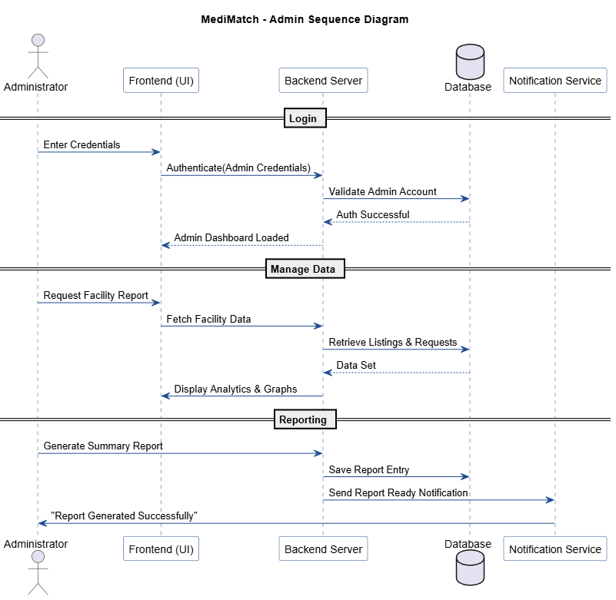
Figure 4.9: Admin Sequence Diagram illustrating MediMatch administrative operations for report generation and facility monitoring.

4.3.7.2 User Sequence Diagram
Figure 4.11 provides the User Sequence Diagram, which is essential for modeling the primary workflow of the entire system: matching a donor to a recipient. It clearly shows the two main actors, Donor Facility and Recipient Facility, interacting with the system's Frontend, Backend, Database, and Notification Service lifelines. The diagram is broken into four sequential steps, starting with Step 1: Request & Listing, where both actors submit their respective data. Step 2 shows the backend's automated Match & Validation process. In Step 3: Notifications, the system proactively alerts both users. The sequence concludes with Step 4: Confirmation, where the actors Approve / Decline the match.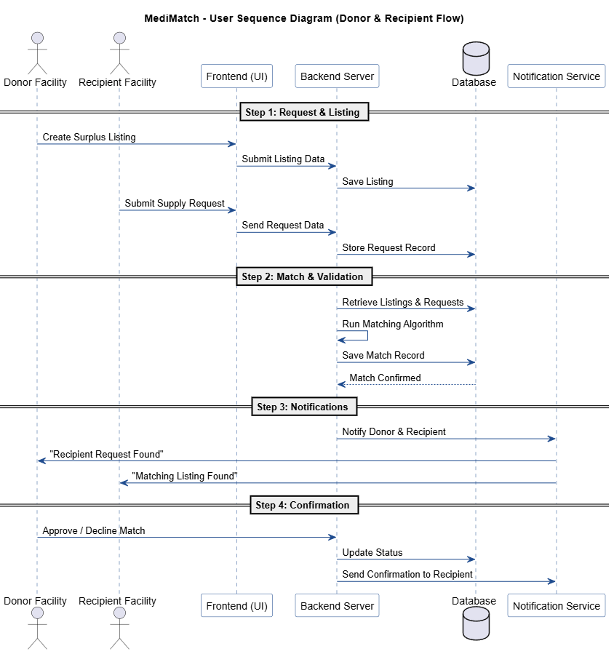Figure 4.10: User Sequence Diagram illustrating donor–recipient interactions through the MediMatch matching and notification workflow.

CHAPTER FIVE
RESEARCH FINDINGS AND ANALYSIS
5.1 Response rate
The Response rate is based on the number of participants who answered or attempted the questionnaire from the total sample. The study targeted a sample size of 80 respondents from various healthcare facilities within Nairobi County. A total of 64 valid responses were obtained, yielding an 80.0% response rate.
This figure surpasses the 70% threshold for excellent survey reliability in the Kenyan context (Mugenda & Mugenda, 2003). The high participation is attributed to the efficiency of digital data collection and the acute relevance of supply chain challenges to the respondents.
5.2 Demographics results
5.2.1 Gender distribution
The research study showed that the gender distribution indicates a female majority, with 53.1% female and 45.3% male respondents. A small minority (1.6%) preferred not to disclose their gender. This distribution is consistent with Kenya's healthcare workforce demographics, where nursing and pharmacy roles often have higher female representation.
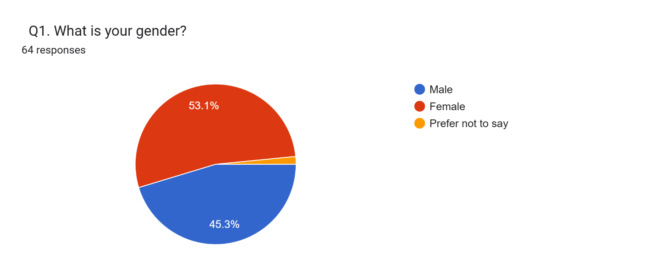
Figure 5.1: Gender Distribution of Respondents
5.2.2 Age Distribution
The majority of respondents (46.9%) fall within the 30-39 years age bracket. Combined with the 18-29 cohort (29.7%), approximately 76.6% of respondents are below 40 years old. This indicates a predominantly young to middle-aged workforce, suggesting that the target user base is digitally literate and likely to adopt new technological solutions like MediMatch without significant friction.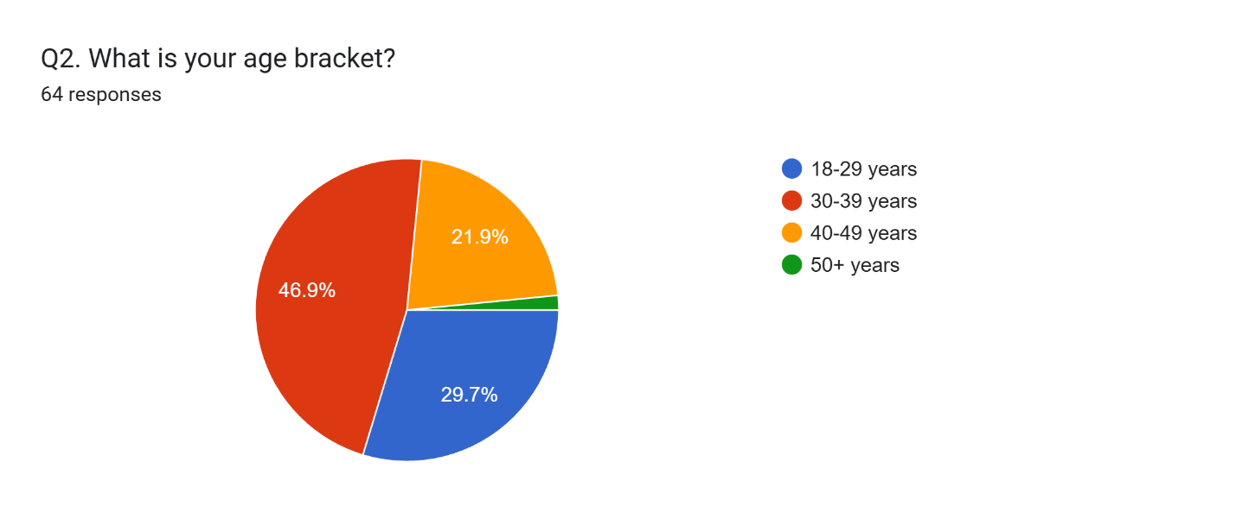
Figure 5.2: Age Distribution of Respondents
5.2.3 Primary Role Distribution
Clinical staff (Nurses/Pharmacists) constitute the largest group at 50.0%, which is appropriate as they are the primary users of medical supplies and are most directly affected by stockouts. The representation of Other staff (26.6%) and Healthcare Administrators (17.2%) ensures that the study captures administrative perspectives on procurement and policy. Technical/IT staff made up the remaining 6.2%.
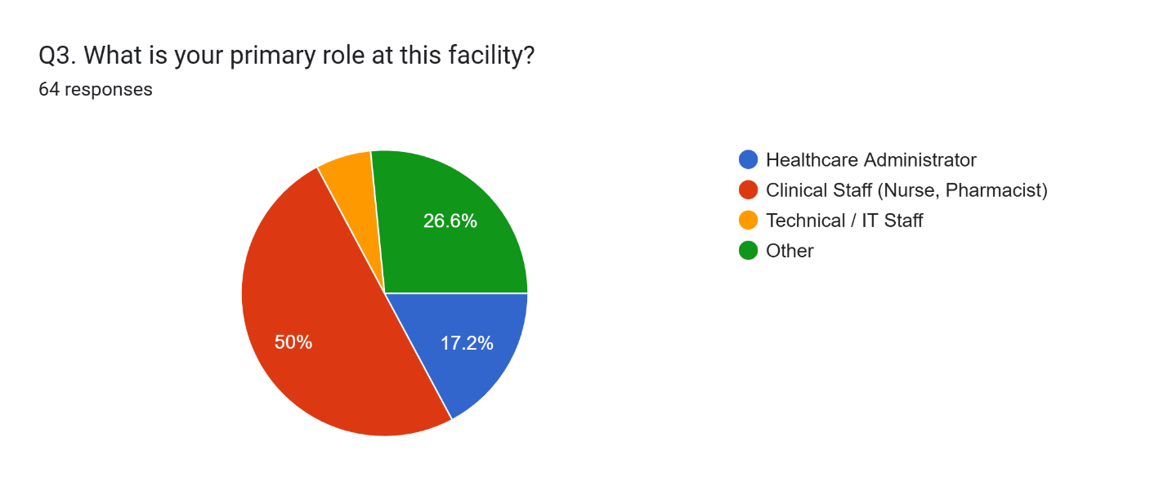
Figure 5.3: Primary Role Distribution at Facilities
5.3.1 Results of how frequent facilities experience stockouts
Respondents were asked to indicate how frequently their facilities experience stockouts. The findings reveal a critical supply consistency issue: 56.3% of facilities experience stockouts at least monthly (12.5% weekly + 43.8% monthly combined). Only 7.8% of respondents indicated their facilities rarely or never experience stockouts. This high frequency of shortages underscores the urgent need for a redistribution mechanism.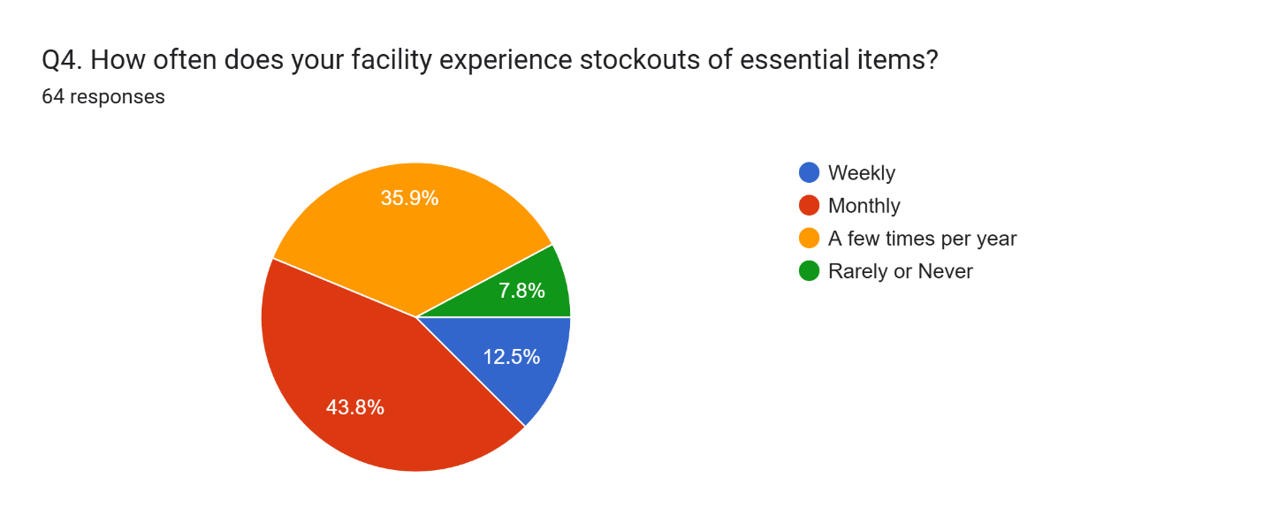
Figure 5.4: Frequency of Stockouts

5.3.2 Current Methods for Handling Surplus

The study sought to understand how facilities currently handle surplus or near-expiry supplies. The data shows that the most common method is Informal Redistribution to other facilities (46.9%), followed by Returning to Central Stores (KEMSA) (28.1%). A significant portion (20.3%) relies on Informal Digital Methods like WhatsApp groups. This indicates that while the intent to redistribute exists, it is currently done through unstructured and inefficient channels.

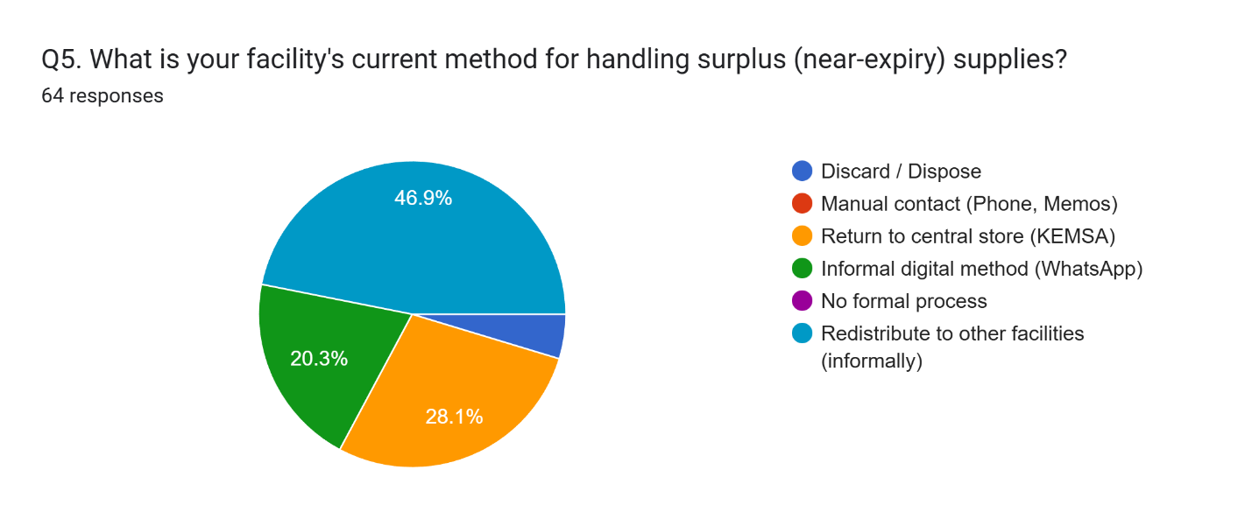Figure 5.5: Current Methods for Handling Surplus

5.3.3 Effectiveness of current methods

When asked to rate the effectiveness of these current methods, 82.8% of respondents rated them as suboptimal. Specifically, 59.4% rated them as Somewhat Effective (implying they are slow), while 23.4% rated them as Ineffective. Only 17.2% of respondents considered their current methods Very Effective. This overwhelming dissatisfaction highlights the gap that a dedicated platform like MediMatch is designed to fill.
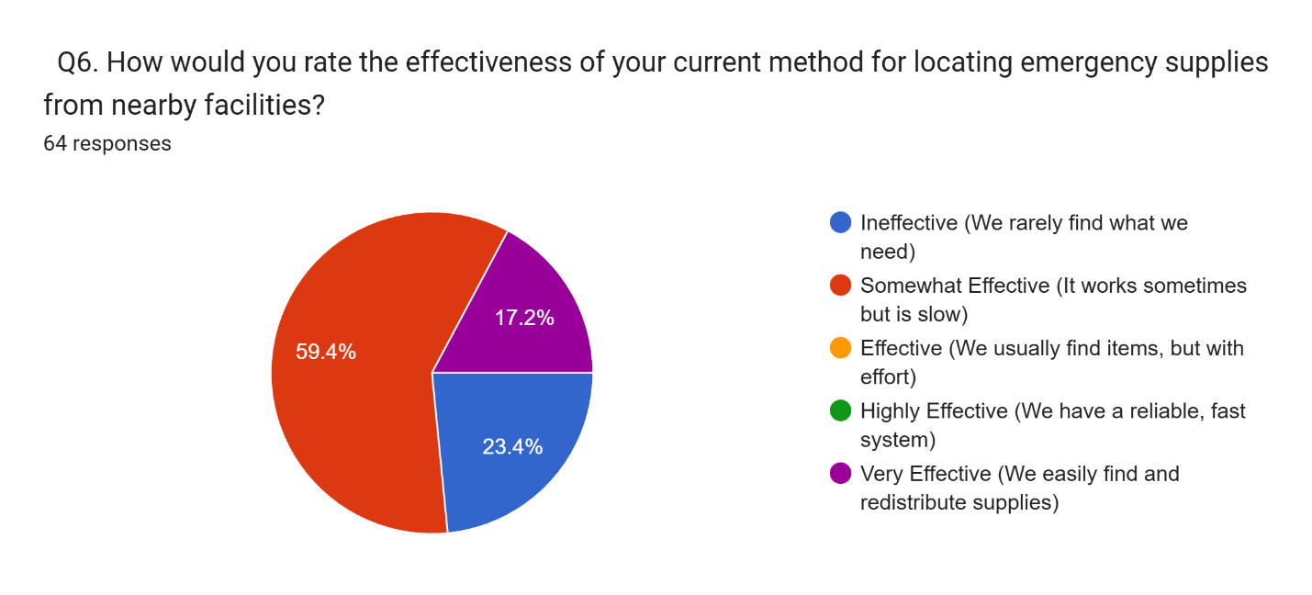Figure 5.6: Effectiveness of Current Methods

5.3.4 Identified challenges
Respondents selected multiple challenges affecting their facilities. Wastage of medicines and supplies was the most cited challenge (57.8%), followed closely by Geographical inequality in distribution (54.7%) and Financial fragility (53.1%). The high citation of wastage creates a paradox when combined with the stockout data, confirming that supplies exist but are not reaching the right locations.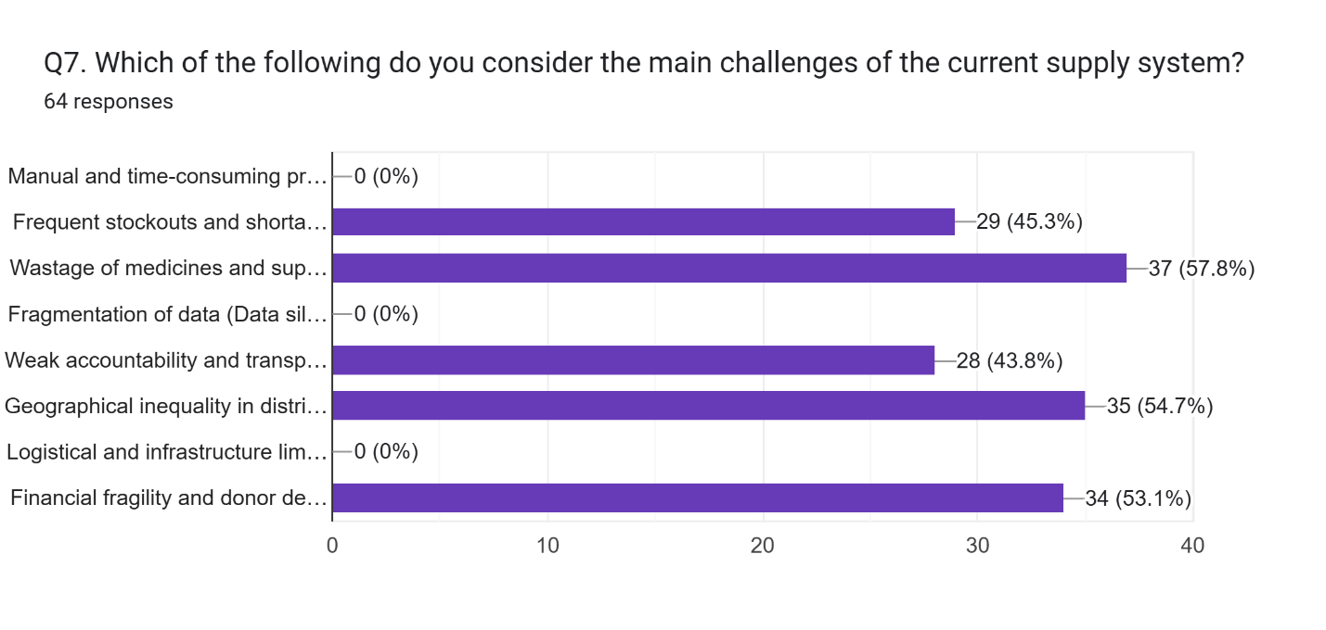
Figure 5.7: Main Challenges of Current Supply System

5.4 Results of benefits of the new app(Medimatch)
5.4.1 Perceived benefits
Respondents indicated which benefits would be most valuable. Data-driven decision-making (Analytics) emerged as the top priority (45.3%), suggesting that healthcare workers value insights into their inventory trends. This was followed by Integration with existing systems (40.6%). Real-time redistribution and Reduction of wastage were tied at 39.1%, reinforcing the alignment between the platform's features and the identified problems.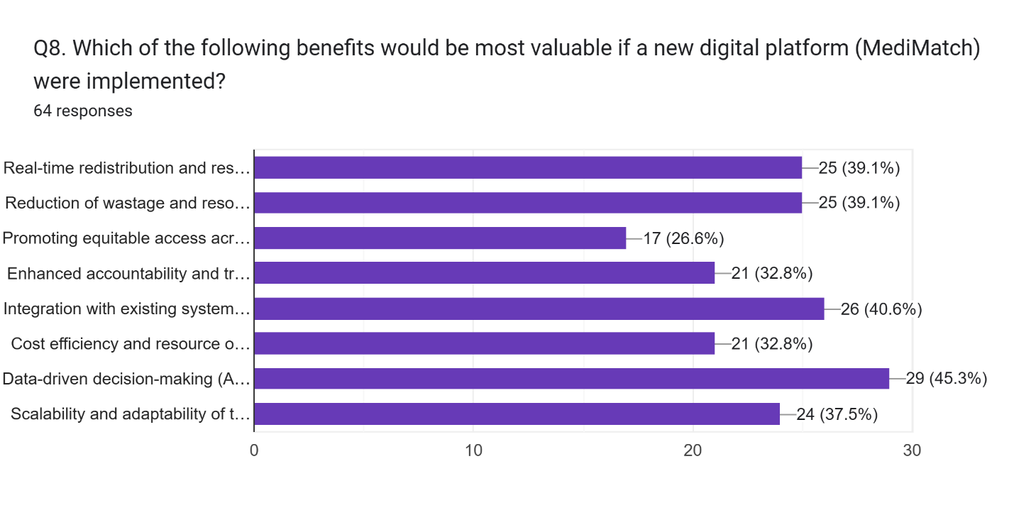
Figure 5.8: Perceived Benefits of MediMatch

5.4.2 Willingness to Pilot
A strong majority shows support for the new system. 57.8% of respondents answered Yes to recommending a pilot at their facility, while 31.3% answered Maybe. Only 10.9% were opposed. This combined positive interest of 89.1% suggests strong market readiness and a willingness among healthcare professionals to adopt digital solutions for supply chain management.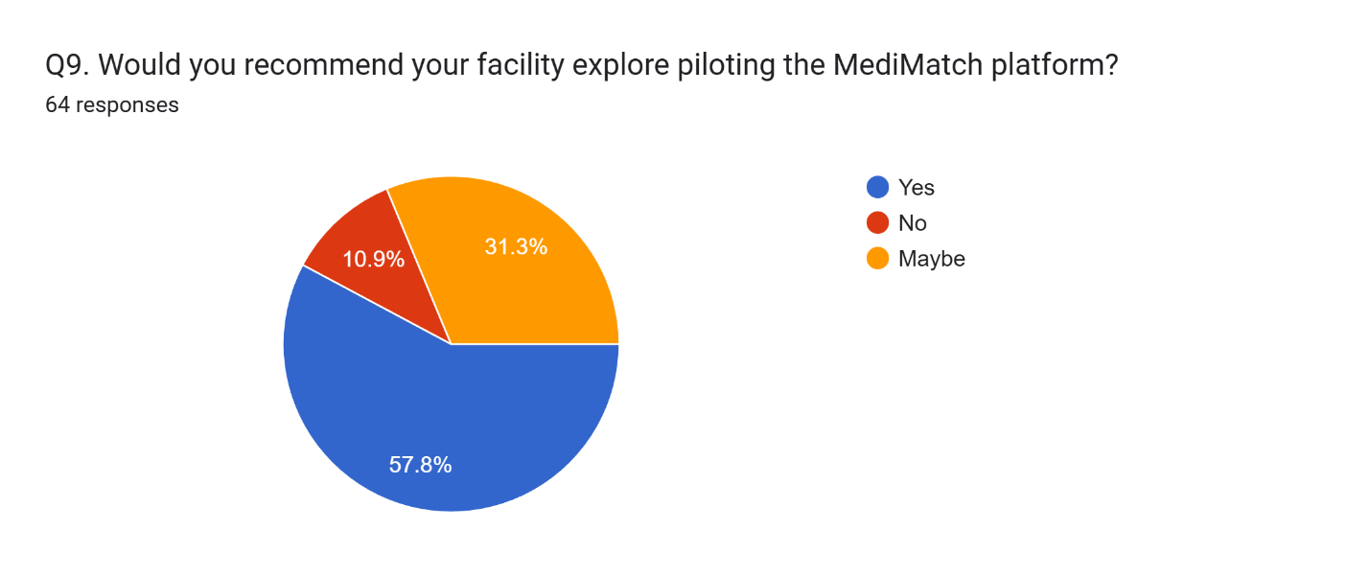
Figure 5.9: Willingness to Pilot MediMatch

CHAPTER SIX
DISCUSSION CONCULSION AND RECOMMENDATIONS
6.1 Discussion
Based on the study, it can be seen that the gender distribution shows a female majority with a response rate of 53.1%. This aligns with the demographic reality of the Kenyan healthcare workforce, particularly in nursing and pharmacy cadres. The study also showed that the age group that dominated was 30-39 years (46.9%), followed by 18-29 years (29.7%). This indicates a workforce that is largely in the early-to-mid stages of their careers, a demographic typically associated with higher digital literacy and adaptability to new software systems.
The data reveals a significant inefficiency in the current supply chain: while 56.3% of facilities face monthly or weekly stockouts, 57.8% of respondents cited wastage as a primary challenge. This confirms the hypothesis of distribution inequality. Currently, 46.9% of facilities attempt to redistribute supplies informally, and 20.3% use WhatsApp groups. However, 82.8% of respondents find these methods ineffective or slow. This clearly validates the need for MediMatch to formalize and accelerate these existing, ad-hoc behaviors.
Lastly, the reception of the proposed system was highly positive. With 89.1% of respondents indicating a willingness to pilot the platform (answering "Yes" or "Maybe"), it is evident that there is a demand for a structured solution. The prioritization of "Analytics" (45.3%) and "Integration" (40.6%) as top benefits suggests that healthcare workers are looking for intelligent systems that can work alongside their current tools, rather than just standalone apps.
6.2 Conclusion
Based on the study done, it can be concluded that the proposed MediMatch system will be beneficial to healthcare facilities in Nairobi. The evidence from the respondent’s data confirms that the current manual and informal systems are failing to balance supply and demand efficiently.
The system will be able to solve the major logistical issues mentioned, specifically by converting the current slow, informal redistribution methods into a centralized, transparent digital marketplace. By addressing the 57.8% of users concerned with wastage and the 54.7% concerned with geographical inequality, MediMatch meets the core expectations of the respondents and should be implemented to support healthcare equity.
6.3 Recommendations
In view of the study findings, it is recommended that the MediMatch system be deployed through a phased pilot program targeting the 57.8% of facilities that expressed a definitive willingness to adopt the platform immediately. This early-adopter strategy leverages the strong market readiness indicated by the 89.1% combined positive interest to create a reliable feedback loop for refining the system. Furthermore, since 40.6% of healthcare workers prioritized "Integration with existing systems," it is crucial that the technical roadmap focuses on developing APIs to interface with national platforms like the Kenya Health Information System (KHIS). This interoperability will directly address the issue of data silos and streamline adoption by eliminating the need for duplicate data entry.
To address the broader systemic challenges, it is recommended that policymakers prioritize scaling the platform to marginalized counties, as 54.7% of respondents identified "Geographical Inequality" as a critical failure of the current system. Policy incentives should be introduced to encourage larger hospitals to redistribute surplus stock rather than discarding it, directly tackling the 57.8% concern regarding wastage. Finally, the "Data-driven decision-making" capabilities valued by 45.3% of respondents should be leveraged to forecast stockouts before they occur, provided that such data analytics strictly adhere to the Data Protection Act (2019) to ensure institutional trust and security.
6.4 Future work
The proposed system is currently set for the county of Nairobi. However, given that 54.7% of respondents cited geographical inequality as a major challenge, it is recommendable that the system be scaled up to other counties, particularly marginalized areas where supply disparities are most acute.
To achieve full functionality, MediMatch can be upgraded to include mobile application support for offline access and AI-driven predictive ordering. I believe that such future work can be revolutionary in bridging the gap between supply-rich and supply-deficient facilities across the country.

CHAPTER SEVEN
IMPLEMENTATION (PROTOTYPE FRAMEWORK)
7.1 System Implementation
Implementation can be defined as the pivotal phase where the conceptual designs and theoretical frameworks are transformed into a functional software product. For the MediMatch project, this process involved translating the architectural blueprints from Chapter Four into a live, full-stack web application. System implementation encompassed the configuration of the development environment using containerization, the coding of the backend API and frontend client, the integration of the geospatial database, and the rigorous testing of data flows to ensure operational stability before deployment.
7.2 Technologies Used
The technologies utilized for the development of the MediMatch system are classified into hardware, software, and programming tools, which are described in detail below.
7.2.1 Hardware Platform
The main hardware device used for the creation of this project was a high-performance personal computer. This device served as the primary station for coding the user interface, developing the server-side logic, running local database containers, and compiling the project documentation. The specifications of the machine include an Intel Core i7 processor (2.50GHz), 16GB of RAM to handle the Docker containers and development servers, a 512GB SSD for fast read/write operations, and the Windows 10/11 Pro operating system.
7.2.2 Programming Language
For the creation of this web-based application, the primary programming language used was TypeScript, along with SQL for database management. TypeScript was utilized for both the frontend (React) and backend (Node.js) to ensure type safety and code consistency across the full stack. SQL was employed specifically for defining the database schema and executing complex geospatial queries via the PostGIS extension. The combination of TypeScript and SQL allowed for the creation of a robust, scalable system where data structures are strictly defined and validated.
7.2.3 Programming Tools
The programming tools used for the development and success of this project include:
Visual Studio Code (VS Code)
VS Code served as the primary Integrated Development Environment (IDE). It is highly optimized for TypeScript and React development, offering features like IntelliSense, debugging, and terminal integration, which streamlined the coding process for both the client and server.
Postman
Postman was utilized to test the backend API endpoints independently of the frontend. This tool allowed for the verification of user authentication, listing creation, and matching algorithms by sending raw HTTP requests and analyzing the JSON responses.
Docker & Docker Compose
Docker was used to containerize the PostgreSQL database. This ensured that the development environment, specifically the complex PostGIS spatial extensions, remained consistent and isolated, preventing configuration conflicts on the host machine.
7.2.4 Software Platform
Microsoft Office and Draw.io
Microsoft Word was used to compile the project documentation and thesis report. Draw.io was instrumental in the creation of the system architecture diagrams, Entity-Relationship Diagrams (ERDs), and sequence diagrams presented in previous chapters.
Node.js Runtime
The system relies on the Node.js runtime environment to execute the backend JavaScript code. It provides the event-driven architecture necessary for handling concurrent API requests efficiently.
Git and GitHub
Git was used for version control to track changes in the source code, while GitHub provided a remote repository for backup and collaborative management of the project files.
7.3 Features of the Prototype
-Secure authentication: The system allows only verified healthcare facilities and Administrators to register and log in using secure JWT-based authentication.
-Surplus listing management: The system allows donor facilities to upload details of surplus supplies, including item names, quantities, expiry dates, and images.
-Geospatial matching engine: The system automatically matches supply requests with the nearest available donors using location-based algorithms.
-Real-time messaging: The system allows matched facilities to communicate directly via an integrated chat interface to coordinate logistics.
-Reputation system: The system allows users to rate their interactions, building a trust score for facilities on the platform.
-Interactive mapping: The system visualizes the location of supplies on a dynamic map, helping users assess distance and transport logistics.
-Admin dashboard: The system provides administrators with tools to moderate listings, verify user accounts, and generate system-wide usage reports.
-Notification system: The system notifies users of new matches or messages through in-app alerts to ensure timely responses.
7.3.1 Technical Manual Screenshots
1. Implementation of Geolocation Integration To fulfill the objective of Geolocation integration, the system utilizes the PostGIS extension within PostgreSQL. The code snippet below demonstrates the backend logic used to calculate the distance between the donor and recipient coordinates, ensuring that matches are prioritized by proximity to minimize transport costs.
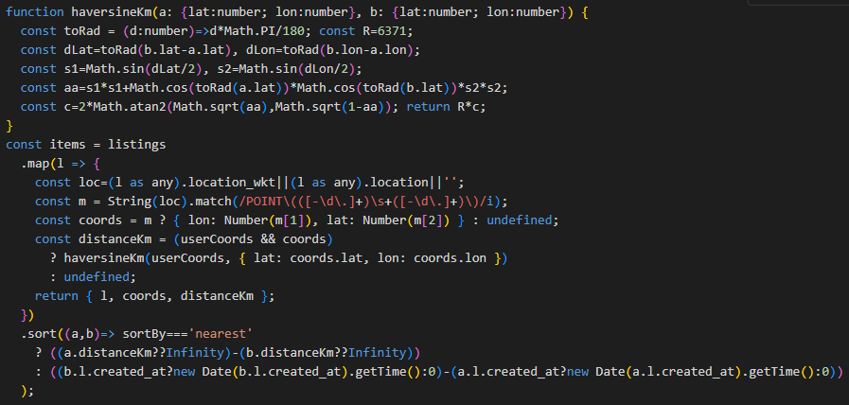
Figure 7.1: Geospatial Query Logic for Proximity Matching
2. Implementation of Real-Time Tracking & Notifications To achieve the objective of Real-Time Tracking, a Notification Service was implemented using an event-driven architecture. This ensures that when a listing is matched, an alert is instantly triggered. The screenshot below shows the notification controller logic that pushes updates to the user.
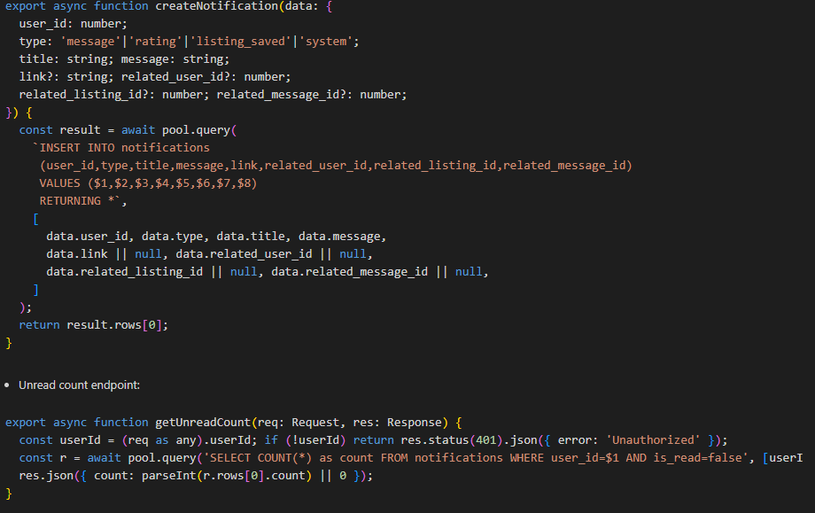
Figure 7.2: Notification Service Logic
3. Implementation of Secure Authentication To meet the objective of Secure Authentication and Role-Based Access, the system uses JSON Web Tokens (JWT) and bcrypt for password hashing. The following code demonstrates the middleware used to verify user tokens and restrict access to specific routes based on the user's role (Donor vs. Administrator).
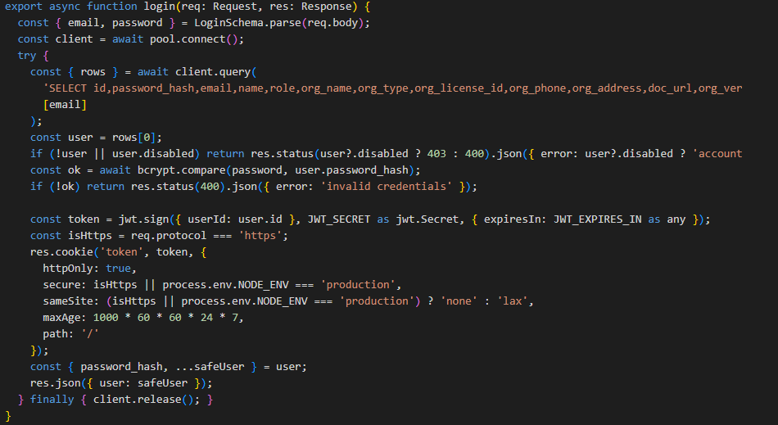
Figure 7.3: Secure Authentication Middleware
4. Implementation of User-Friendly Interface To satisfy the objective of a User-Friendly Interface, the frontend was built using React components designed for accessibility and responsiveness. The code structure below highlights the modular design of the "Create Listing" form, ensuring ease of use for healthcare workers with varying digital literacy.
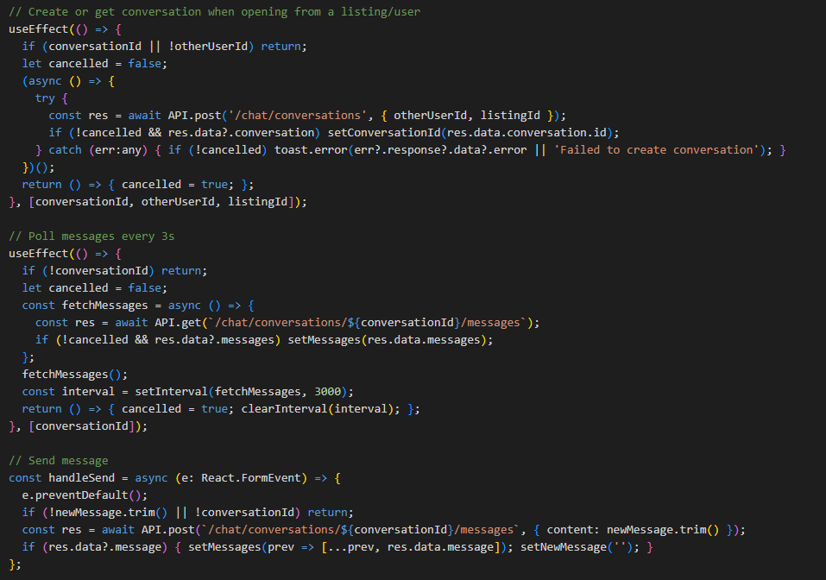
Figure 7.4: Frontend Component Structure
7.3.2 User Manual Screenshots: Main Activity Step by Step
This section outlines the primary user journey within the MediMatch application, demonstrating the step-by-step process for authentication, listing creation, matching, and communication.
Step 1: Secure User Login: Users are required to log in to access the platform. Upon launching the application, they are presented with a secure login screen where they enter their credentials (email and password) to authenticate their session.

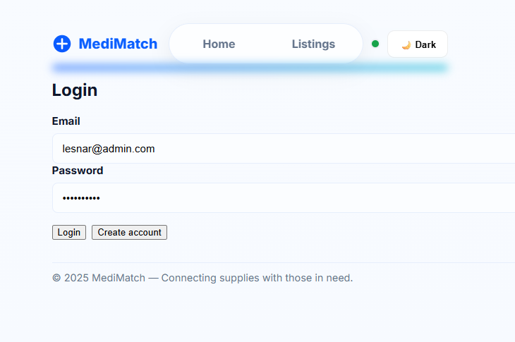
Figure 7.5 User Login Screen
Step 2: Creating a Surplus Listing: Once logged in, the user is directed to the main Dashboard. From here, a donor facility can choose to list a new item. They click the Create Listing button and fill in the form with details about the surplus medical supply.
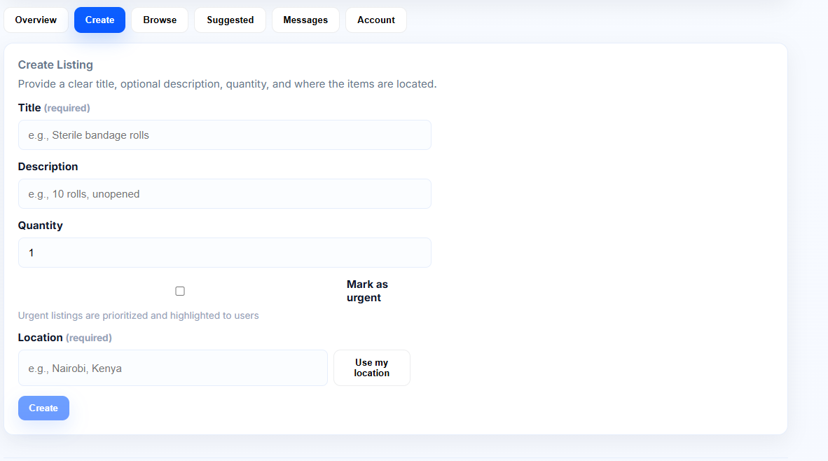
Figure 7.6 Create Surplus Listing
Step 3: Viewing Matches: After submitting a listing, the system processes the data. Recipient facilities can view these items. When a match is found based on location and need, the system displays the Suggested Matches view
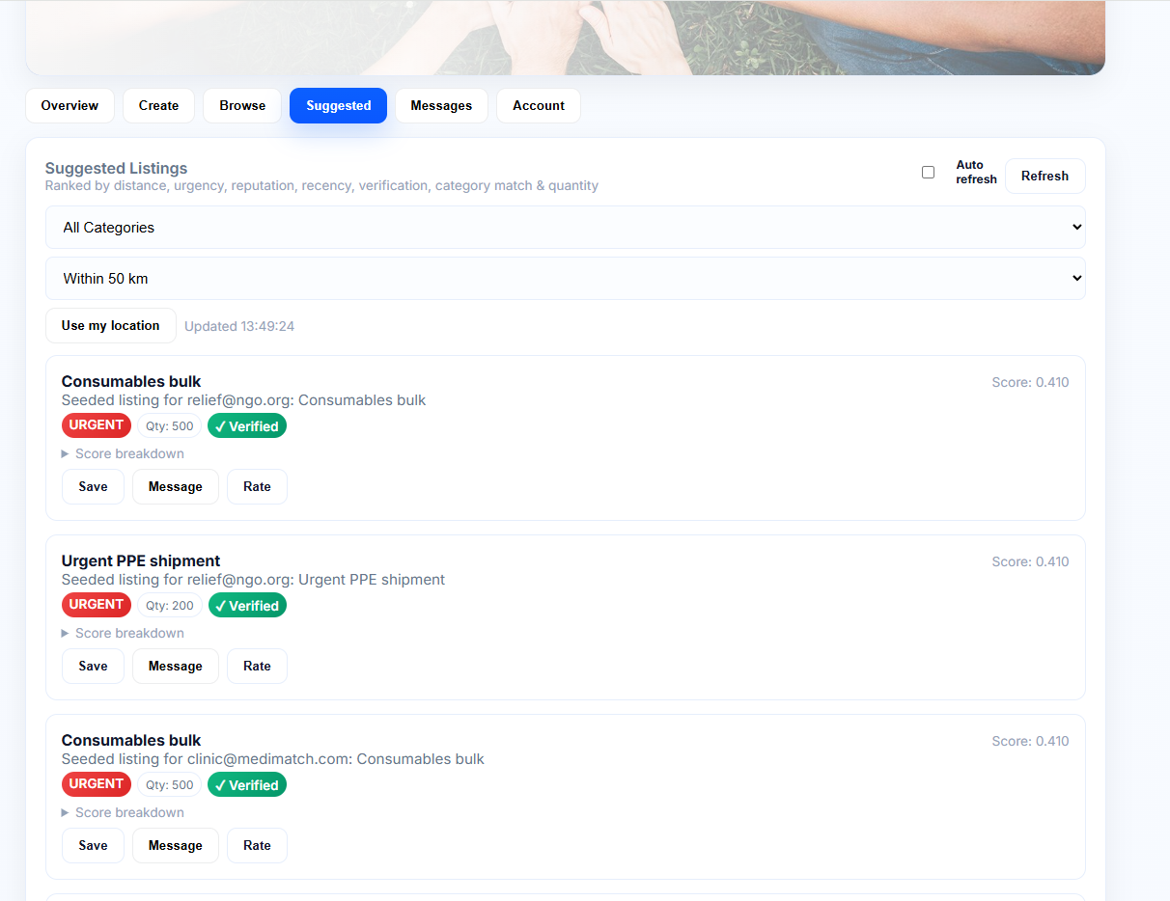
Figure 7.7 Matching results
Step 4: Secure Communication: Users can initiate a conversation to finalize the transfer. The chat interface allows for secure, direct communication between the donor and the recipient.
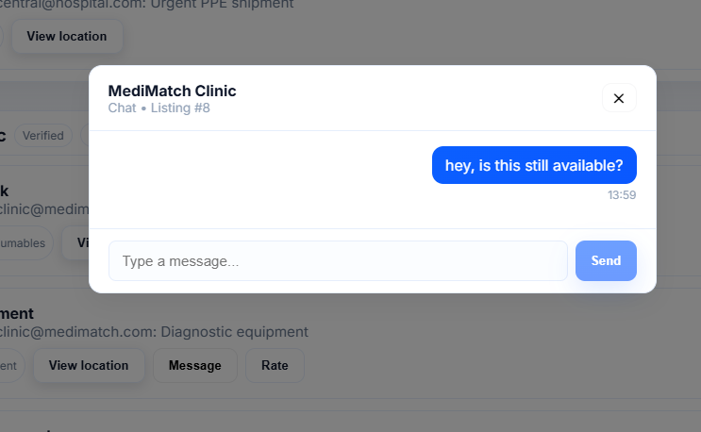
Figure 7.8 Secure Messaging
Step 5: Administrator Management: The Administrator has a specific view to manage the platform. The Admin Dashboard allows for the verification of new facility accounts and the generation of supply distribution reports.
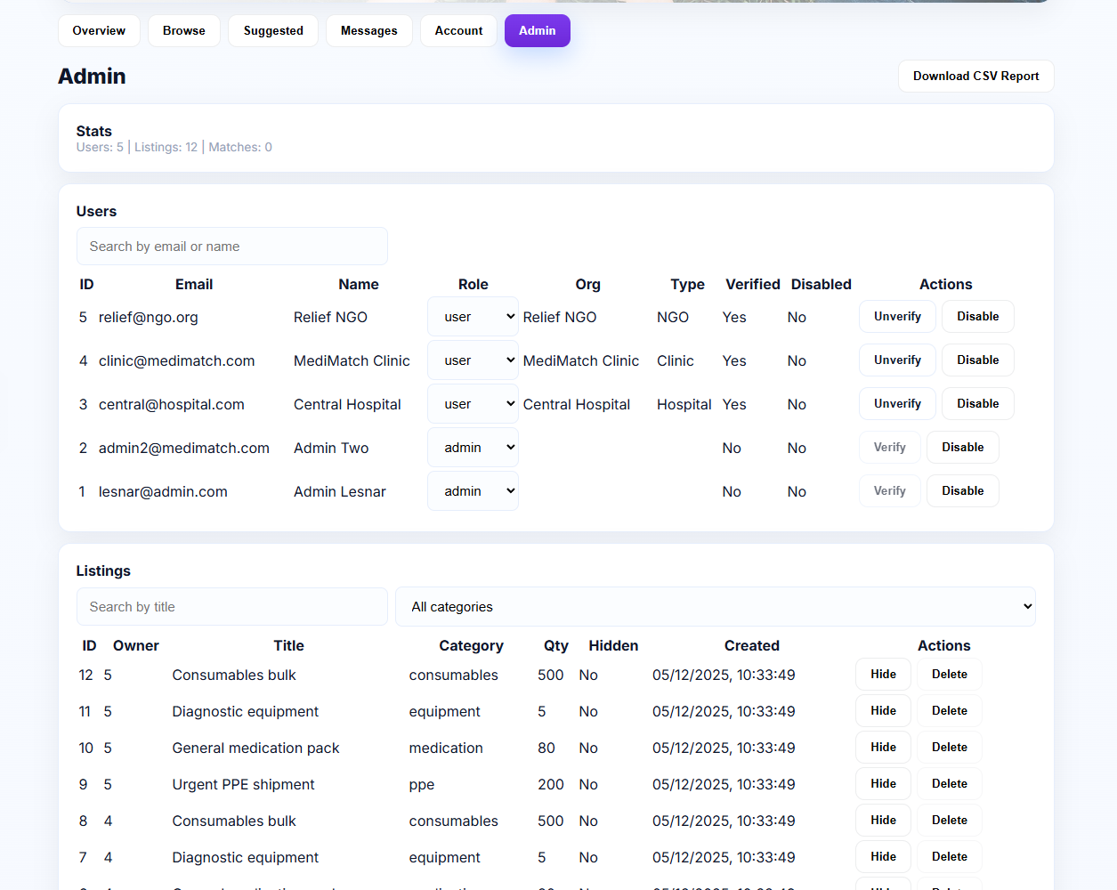
Figure 7.9 Admin Control Panel

7.4 Database Management System
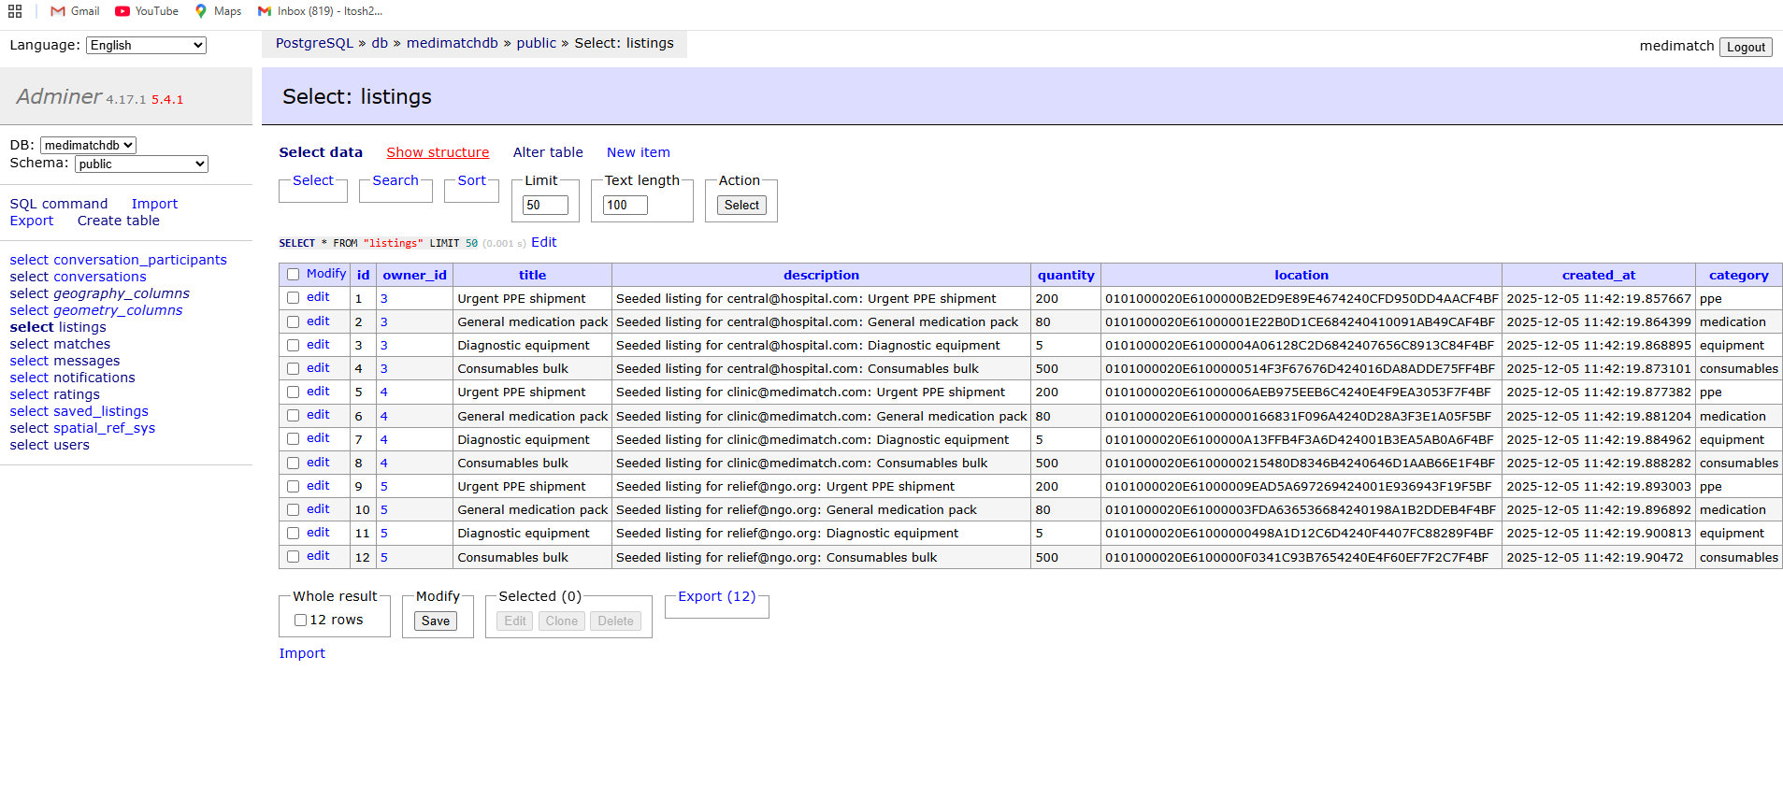
Figure 7.10 Database Structure- users

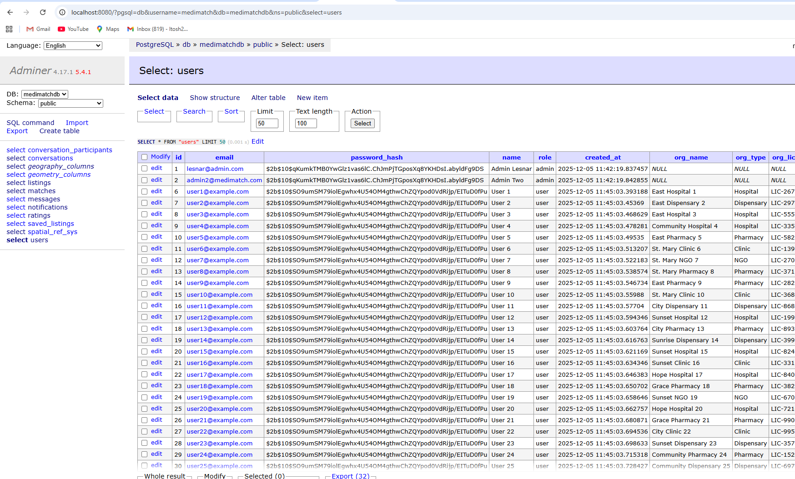
Figure 7.11 Database Structure- listings
The database management system is built on PostgreSQL with the PostGIS extension. This structure supports the complex relationships between users, listings, and conversations, while specifically enabling the geospatial queries required to calculate distances between healthcare facilities
The schema ensures data integrity through foreign keys and unique constraints on user emails and listing IDs.

REFERENCES
Davis, F. D. (1989). Perceived usefulness, perceived ease of use, and user acceptance of information technology. MIS Quarterly, 13(3), 319–340.
HealthcareMEA. (2025). Supply chain challenges and the impact of wastage in East African healthcare. Healthcare Middle East & Africa.
Kenya Medical Supplies Authority (KEMSA). (2025). Supply chain performance and order-fill rates: Mid-year report 2025. Nairobi: KEMSA.
Kenya Ministry of Health. (2023). National health supply chain strategy and universal health coverage. Nairobi: Ministry of Health.
Kenya News Agency. (2025). Turkana County receives KSh 119 million in emergency medical supplies. Government of Kenya.
Kenyan News Agency. (2025). Addressing stockouts: Inter-county redistribution measures.
Kumar, S., & Associates. (2023). Logistics challenges in international medical aid redistribution. Journal of Humanitarian Logistics.
Lee, H. L., Padmanabhan, V., & Whang, S. (1997). Information distortion in a supply chain: The bullwhip effect. Management Science, 43(4), 546–558.
LifeNet International. (2023). Capacity building and supply chain strengthening in Sub-Saharan Africa. LifeNet International Annual Report.
MedShare. (2024). Recovering surplus medical supplies: Global impact report. Retrieved from https://www.medshare.org
Ministry of Health Kenya. (2020). Kenya National e-Health Policy 2016–2030. Nairobi: Ministry of Health.
Mugenda, O. M., & Mugenda, A. G. (2003). Research methods: Quantitative and qualitative approaches. Nairobi: Acts Press.
Nation Africa. (2024). Global Fund audit reveals inconsistencies in Kenya’s stock management. Daily Nation.
NHS England. (2022). NHS supply chain redistribution program: Lessons from the COVID-19 pandemic. London: National Health Service.
OECD. (2023). Health at a Glance 2023: Procurement and redistribution efficiency in developed health systems. Paris: OECD Publishing.
Ouma, P., & Wanjiru, J. (2023). Sustainability challenges in donor-funded healthcare supply chains. East African Medical Journal.
Republic of Kenya. (2019). The Data Protection Act. Nairobi: Government Printer.
Rogers, D. S., & Tibben-Lembke, R. S. (2001). Going backwards: Reverse logistics trends and practices. Reno, NV: Reverse Logistics Executive Council.
Smith, A., & Patel, R. (2022). Scalability of digital redistribution platforms in low-resource settings. International Journal of Digital Health.
South African Health Review. (2023). Provincial medical store redistribution strategies during epidemic surges. Health Systems Trust.
The Star. (2025). Impending shortage of HIV medicines due to donor funding cuts. The Star Newspaper.
VillageReach & Ministry of Health. (2025). Health information system fragmentation: Integrating iLMIS, eCHIS, and KHIS.
Weekly Vision. (2025). County debts and recurring stockouts in public facilities.
World Health Organization. (2022). Global strategy on digital health 2020-2025: Ethics and governance. Geneva: WHO.
World Health Organization Africa. (2023). Digital infrastructure and demand visibility in African health supply chains. Brazzaville: WHO Regional Office for Africa.
Yadav, P. (2015). Health product supply chains in developing countries: Diagnosis of the root causes of underperformance and an agenda for the future. Health Systems & Reform, 1(2), 142–154.

APPENDICES
9.1 Appendix A: Questionnaire/Interview schedule

MediMatch Project: Healthcare Supply Chain Questionnaire
Thank you for participating in this research. This questionnaire aims to understand the current challenges in medical supply distribution and to gather feedback on the proposed "MediMatch" redistribution platform. Your responses are anonymous and will be used for academic purposes only.

Section A: Respondent Bio-Data
1. What is your gender?
☐ Male
☐ Female
☐ Prefer not to say
2. What is your age bracket?
☐ 18-29 years
☐ 30-39 years
☐ 40-49 years
☐ 50+ years
3. What is your primary role at this facility?
☐ Healthcare Administrator
☐ Clinical Staff (Nurse, Pharmacist)
☐ Technical / IT Staff
☐ Other

Section B: Knowledge and Experience in the Topic

4. How often does your facility experience stockouts of essential items?
☐ Weekly
☐ Monthly
☐ A few times per year
☐ Rarely or Never
5. What is your facility's current method for handling surplus (near-expiry) supplies?
☐ Discard / Dispose
☐ Manual contact (Phone, Memos)
☐ Return to central store (KEMSA)
☐ Informal digital method (WhatsApp)
☐ No formal process
6. How would you rate the effectiveness of your current method for locating emergency supplies from nearby facilities?
☐ Ineffective (We rarely find what we need)
☐ Somewhat Effective (It works sometimes but is slow)
☐ Effective (We usually find items, but with effort)
☐ Highly Effective (We have a reliable, fast system)

Section C: Project Objectives
7. Which of the following do you consider the main challenges of the current supply system?
(Selected from Chapter 2.2.1 - Please check all that apply)
☐ Manual and time-consuming processes
☐ Frequent stockouts and shortages
☐ Wastage of medicines and supplies
☐ Fragmentation of data (Data silos)
☐ Weak accountability and transparency
☐ Geographical inequality in distribution
☐ Logistical and infrastructure limitations
☐ Financial fragility and donor dependence
8. Which of the following benefits would be most valuable if a new digital platform (MediMatch) were implemented?
☐ Real-time redistribution and responsiveness
☐ Reduction of wastage and resource utilization
☐ Promoting equitable access across regions
☐ Enhanced accountability and transparency
☐ Integration with existing systems (like KHIS/iLMIS)
☐ Cost efficiency and resource optimization
☐ Data-driven decision-making (Analytics)
☐ Scalability and adaptability of the platform

Section D: Recommendation
9. Would you recommend your facility explore piloting the MediMatch platform?
☐ Yes
☐ Maybe

9.2 Appendix B: Work plan in Grant Chart format
Table 9.1: Project Implementation Work Plan (Gantt Chart Schedule)
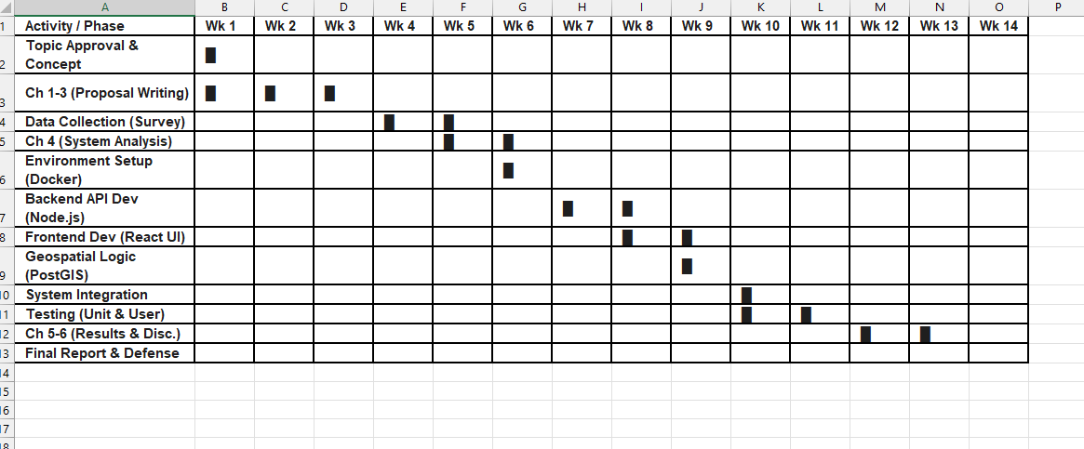

9.3 Budget
Table 9.2: Project Budget Breakdown
